

z/OS ISPF Git Interface: Easy Access to Git from z/OS ISPF User Guide

**Software Version: 3.14**

**March 2022**

**Contents**

Contents

About ZIGI 5

Revision History 5

Overview (What You Should Know but May Not) 7

Pre-Requisites (Installing Git) 7

Installing ZIGI 8

Accessing the ZIGI Git Repository 8

Additional Options 9

Using CBTTape 9

Dovetail Enhancements 9

Restrictions and Caveats 10

Starting ZIGI the First Time 10

ISPF Dialog Notes 14

The ZIGI Local Repositories Panel 15

Action Menu Bar 16

The Repository Commands Menu 16

The Help Menu 16

Clone 17

Config 18

Connect 19

Create 20

GITHELP 22

Options Menu Assist 23

Select Command 23

Sort Selections Pop-Up Menu 23

SSH Public Key 24

Row Selections 25

Select Option 25

Info Option 25

View Option 25

Delete Option 25

/ Row Selection Prompt 26

The ZIGI Current Repository Panel 27

Action Bar Menus 29

The General Actions Menu 29

The Local Repo Actions Menu 29

The Remote Repo Actions Menu 30

The Handy Functions Actions Menu 30

The Help Actions Menu 31

AddAll Command 31

AddDsn Command 31

Select (S) and Add (A) Commands 32

Add Binary (AB) Function 32

Browse (B) 33

Branch Command 33

Check Command 33

Commit Command 33

Convert Repository (CONVREPO) Command 34

Diff Command 35

Extract Command 36

Flow Command 38

GitCmd Command 40

Git Help 41

GitLog Command 41

Grep Command 42

Network 43

Options Menu Assist 44

Pull 44

Push 44

Readme 45

Replace 45

Remote Command 46

Set Command 46

Snapshot 47

Stash 47

Stash List (STASHL) Command 48

Branch 48

Diff 48

Pop 49

Remove 49

Show 49

Status Command 49

Tag 49

TagList 50

View 51

Row Selections 52

Select Option 52

Add Option 52

Browse and View 52

Diff 52

History 63

Undo (U) 63

Remove (RM) 63

Rename (RN) 63

/ Row Selection Prompt 63

The ZIGI PDS Member List 64

Action Bar Menu 65

Locate Command 65

Commit 65

GitLog 65

Grep 65

Sort Command 66

Status 66

Reset-IDs Command 66

Options (O) Command 67

Member Select Option 67

Add Option 67

AddBin Option 68

AddForce (AF) Option 68

Browse Options 68

Diff Option 68

History Option 69

Ignore 71

Remove and Rename 71

Undo 71

View 71

/ Row Selection Prompt 72

Typical ZIGI Activities 73

Creating a New Repository (Local and Remote) 73

Adding a Remote Repository 73

Updating a Local Repository 73

Pulling Updates from the Remote Repository to Update the Local Repository 74

Pushing Updates to the Remote Repository 74

Changing to a Different Existing, Or New, Branch 74

What is Happening Under the Covers? 75

ZG - ISPF Command 76

ZGBATCH - Execute ZIGI in Batch 68

Timing (For Those Interested) 69

Appendix A: Installing Git 70

Appendix B: Using ZGINSTALL.REX 72

Appendix C: Learning Resources 69

Appendix D: User Exits 70

Appendix E: Common Problems 71

# About ZIGI

Git is becoming pervasive for source code management (SCM) and the z/OS developer has been left out until now.

The z/OS ISPF Git Interface (AKA ZIGI) provides the z/OS developer with a very useable Git client. ZIGI is open-source and can be found at [https://ZIGI.rocks](https://ZIGI.rocks/).

**Author**: Henri Kuiper (henri@zdevops.com): [zdevops.com](http://zdevops.com/)

**Author**: Lionel B. Dyck ([lbdyck@gmail.com](mailto:lbdyck@gmail.com))

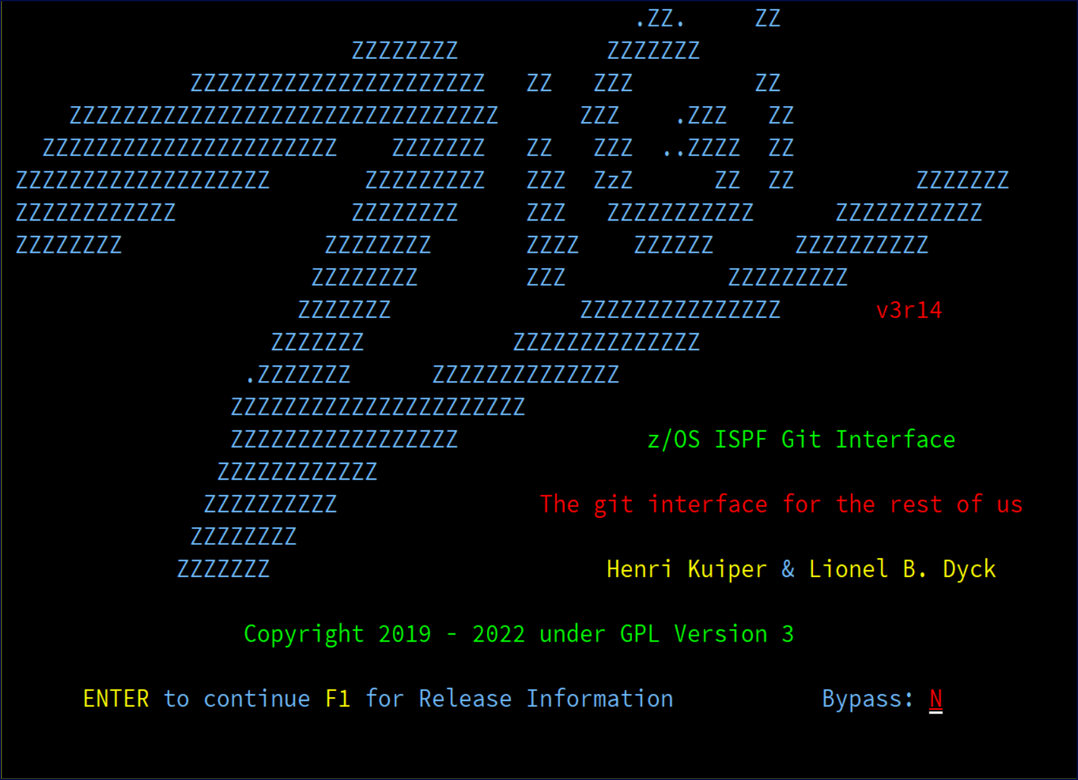

# Revision History

The revision history for ZIGI and the *z/OS ISPF Git Interface: Easy Access to Git from z/OS ISPF User Guide* is listed below. The most recent update is listed first.

|  |  |  |
| --- | --- | --- |
| **Version** | **Date** | **Description of Revision** |
| 1.16 | Tbd | Updates for version 3.14 |
| 1.15 | 06/03/2021 | Numerous changes for release 3.11 |
| 1.14 | 01/09/2021 | Update to add DIFF command information. |
| 1.13 | 12/05/2020 | Underwent full editing pass by tech writer.  Added Dovetail Enhancements Topic, Connect topic, AddForce Option topic, Ignore Option topic, and Appendix D: User Exits.  Updated images.  Changes to the Create topic, Delete Options topic, and AddDsn Command topic. |

|  |  |  |
| --- | --- | --- |
| **Version** | **Date** | **Description of Revision** |
|  |  | Renamed Appedix D: Common Problems to Appendix  E: Common Problems. |
| 1.12 | 08/27/2020 | Update with informtion on Read Only repositories |
| 1.11 | 08/08/2020 | Updates for V3R01 changes |
| 1.10 | 07/17/2020 | Updates for Version 3.00-rc |
| 1.9 | 07/14/2020 | Replace ROLLBACK with extract. Changed install.sh to zginstall.rex.  Added documentation on zginstall.rex in Appendix B and changed Appendix B to C and Appendix C to D.  Added MV as an alias of RN (Rename). Updates for Version 3.00-rc. |
| 1.8 | 06/09/2020 | Add ZGBatch |
| 1.7 | 05/11/2020 | Add Appendix C: Common Issues |
| 1.6 | 05/08/2020 | Add information on support for Load Modules |
| 1.5 | 05/06/2020 | Full user guide editing pass by Tech Docs |
| 1.4 | 04/20/2020 | Updates for V2R8  New ZG command for use with ISPF outside of ZIGI |
| 1.3 | 03/29/2020 | Add Appendix B: Learning Resources |
| 1.2 | 03/27/2020 | Updates for V2R7.  Updated Action Bar for Current Repository. New Check command for Current Repository.  Support for PDS Member file extensions on the OMVS file copy. |
| 1.1 | 03/08/2020 | Updates for V2R5.  Change history in action bar.  New Info command for current repository.  Current repository SET new option to change Prefix. |
| 1.0 | 03/01/2020 | Major updates for V2R5 |
| 0.9 | 01/27/2020 | Updates for version 2 release 0 |
| 0.6 | 12/05/2019 | Numerous changes for 1.4 |
| 0.5 | 11/26/2019 | Numerous changes for 1.2 |

|  |  |  |
| --- | --- | --- |
| **Version** | **Date** | **Description of Revision** |
| 0.4 | 11/21/2019 | Add updated GITLOG information |
| 0.3 | 11/20/2019 | Updated panels for v1r1. Added appendix for Git install.  Added Sort and Reset commands for member list display. |
| 0.2 | 11/17/2019 | Minor additions |
| 0.1 | 11/11/2019 | Creation |

# Overview (What You Should Know but May Not)

This topic provides a description of Git and ZIGI.

Git is a version control system that is very popular in the distributed environment. Thanks to the great team over at Rocket Software, it is available (and has been for a few years) for the z/OS environment. The main drawback is there has not been a user-friendly, mainframe-based, solution until

now. ZIGI allows the mainframe developer to participate in the world of Git. There is a wealth of information available on Git. Open your favorite web browser and do a search or go directly to [github.com](http://github.com/) where free accounts and many open-source projects, including ZIGI, are available.

ZIGI was developed to provide the mainframe developer with a user-friendly interface to Git that works the way any other mainframe user interface applications work, making it possible for the developer to continue to use the development tools that are familiar, easy to use, and that enhance their productivity. That means that all the ISPF capabilities are available to the ZIGI user as well as the ability to integrate their SCM requirements using Git.

## Pre-Requisites (Installing Git)

This topic includes an image that explains the overview of Git processing.

See Appendix A: Installing Git for a checklist for installing Git and the additional tools it requires, which are open source and free.

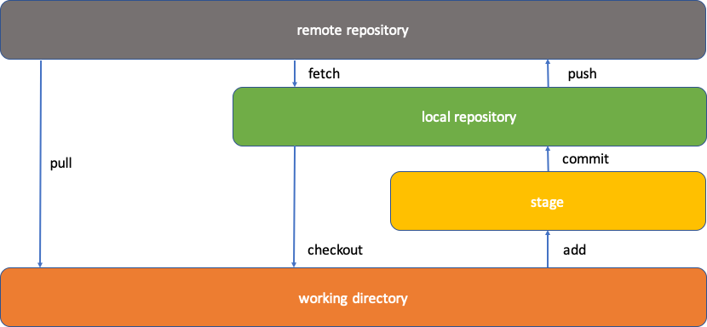

*Figure 1: Overview of Git Processing*

# Installing ZIGI

## Accessing the ZIGI Git Repository

This topic explains how to access the ZIGI Git Repository at GitHub.

**Procedure**

1. Create an account at GitHub.com, and then add your (Mainframe) SSH Public Key to your account.
2. If you have not added your SSH keys to your GitHub settings, provide your username and password at the prompt.

It is highly recommended that you add your public SSH key to your GitHub account settings to eliminate the prompts for userid and password.

1. Sign into OMVS, and then change to the directory where you are installing ZIGI.
2. Do one of the following:
   * If your SSH key is already generated and added to your GitHub account, execute the following command:

git clone git@github.com:zigi/zigi.git cd zigi

sh install.sh

* + If you haven’t added your SSH key to Github clone via https, execute the following command:

git clone https://github.com/zigi/zigi.git [provide GitHub username and password when prompted] cd zigi

sh install.sh

### Additional Options

This topic provides an overview on how to download ZIGI from the internet, unzip the files, upload the files to your mainframe, and then run the installer if you're unable to connect your mainframe to GitHub.

If you do not have the option to connect your Mainframe directly to GitHub, you can download the zip files, unzip them, upload them to your mainframe, and then run the installer.

The latest stable version of ZIGI can be downloaded [here](https://github.com/zigi/zigi).

When running the zginstall.rex script, there are a few prompts asking for a high-level qualifier (HLQ) for the ZIGI ISPF data sets to be created under. The ZIGI partitioned data sets are allocated as PDSE

partitioned data sets. After the zginstall.rex completes, exit OMVS, return to native ISPF, and then execute the ZGSTAT exec as documented in the zginstall.rex report. That applies the ISPF statistics to the PDS members of ZIGI.

To use the ZG command, it must be copied from the ZIGI.EXEC library into a library in the standard SYSEXEC, or SYSPROC, allocation.

For more information, check out the [ZIGI wiki](https://github.com/zigi/zigi/wiki).

## Using CBTTape

**Procedure**

1. Open your browser and navigate to <https://www.cbttape.org/updates.htm> and look for File 997. If you don’t see File 997 on the updates page then go to <https://cbttape.org/cbtdowns.htm> and look for File 997.
2. Download file 997 to your workstation and unzip.
3. Binary upload the resulting XMIT file to z/OS using RECFM=FB LRECL=80.
4. From TSO, or ISPF Option 6, issue **RECEIVE INDS**(*upload-file-name.xmit*).
   1. Enter a data set name or take the default.
5. Open the resulting PDS and execute the $INSTALL member, which receives the EXEC and PANELS members into full partitioned data sets.
6. Edit the PDS member STUB to customize for your site, and then copy it into a library in your SYSPROC or SYSEXEC allocations under the name ZIGI.
7. Start ZIGI from any ISPF Panel by entering **TSO %ZIGI**.
8. To use the ZG command, it must be copied from the ZIGI.EXEC library into a library in the standard SYSEXEC, or SYSPROC, allocation.

# Dovetail Enhancements

ZIGI now supports the Dovetail enhanced getpds and putpds commands. These commands significantly speed up the copying of PDS members between the OMVS filesystem and the z/OS partioned data sets.

The use of the Co:Z Toolkit is subject to Dovetail's [Community License](https://dovetail.com/docs/cozinstall/licenses.html).

Access the Dovetail Co-Processing Toolkit here [https://dovetail.com/downloads/coz](https://dovetail.com/downloads/coz/index.html).

Along with the getpds and putpds, which greatly enhances ZIGI, there are also:

* Co:Z SFTP
* Co:Z Launcher
* Co:Z Dataset Pipes
* Co:Z Batch

These commands are not fully exploited with the ZIGI 3.14 release as there are more capabilities available with them.

**Note:** This is optional. The standard OMVS cp command is used if these commands are not available.

# Restrictions and Caveats

This topic explains the restrictions and caveats you should know when using ZIGI. ZIGI is designed to work under ISPF, using OMVS services, and interfaces to Git. There are some restrictions and/or caveats that you should be aware of:

* VSAM, BDAM, and ISAM are not supported.
* While ZIGI utilizes Git, only those git repositories that are configured for ZIGI can be managed by ZIGI. All others may be cloned, and the conversion utility used after some (or a lot of) manual changes.
* File extensions for the OMVS copy of PDS members is supported with the restriction that each PDS may only have one file extension mapped to it.

Load modules are supported from data sets with RECFM=U. The restriction is for versions of z/OS prior to 2.4, the following PTFs must be installed:

* z/OS 2.2 | UJ01358
* z/OS 2.3 | UJ01356

# Starting ZIGI the First Time

This task explains how to start ZIGI for the first time.

**About this task**

**Procedure**

1. In ISPF, use option 3.4 and enter the HLQ provided during the installation process or enter DSLIST hlq on the ISPF command line.
2. Select the EXEC data set using Browse, Edit, or View.

**Note:** ZIGI saves its repository in an ISPF table in the data set referenced by ISPTABL, but if that DD is not used then it uses the DD ISPPROF as the location for the table.

1. Next to the ZIGI member, enter EX to execute it.

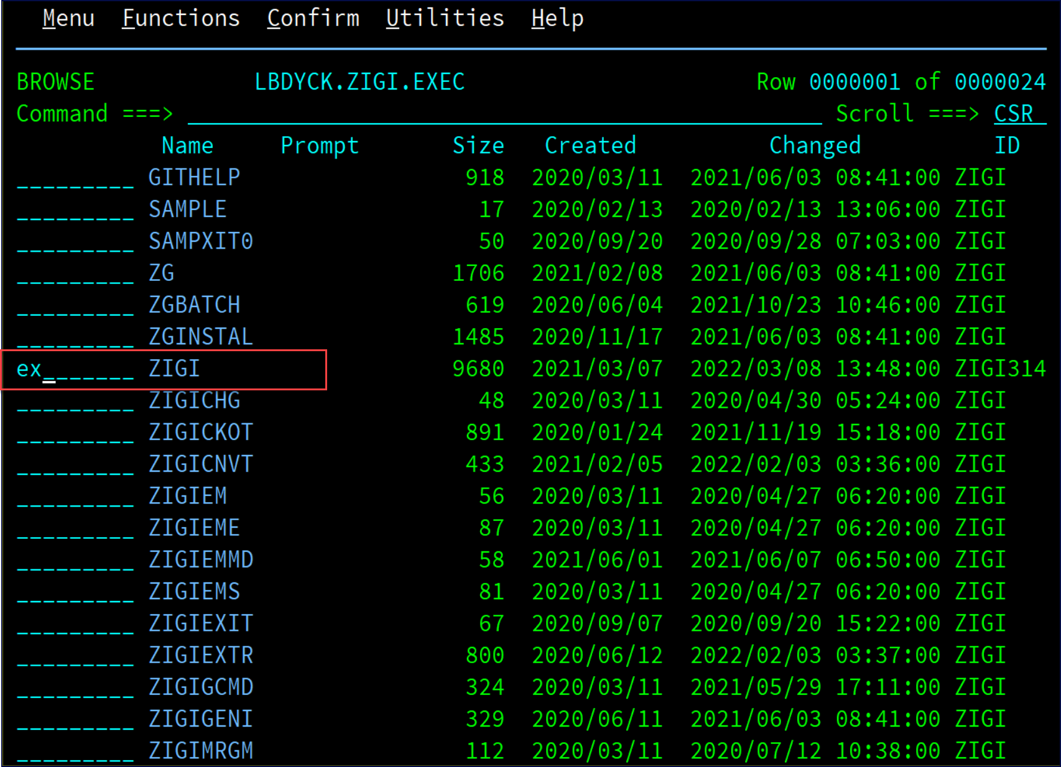

This exec is the main ZIGI code and dynamically allocates the EXEC library using ALTLIB and the PANELS library using LIBDEF.

1. A more permanent option is to edit this sample REXX code, make the necessary customizations, and place it in a library in your SYSEXEC concatenation and invoke from any ISPF panel using the command TSO %ZIGI. This sample can be found in the provided EXEC library under the name SAMPLE.

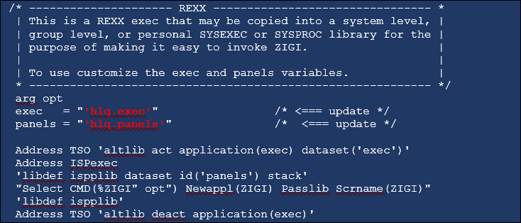

The ZIGI Splash panel is presented.



1. Next, you are prompted for your username and e-mail along with three ZIGI processing defaults:
   1. It is recommended that the **PDSE Member Generations** default value is 0 unless you have a tool that supports working with member generations. See [PDSEGEN on file 969](http://www.cbttape.org/).
   2. The **Display Options Popup** option changes the behavior of point-and-shoot so that on table panels, a click above the table displays the commands pop-up and anywhere in the table the line selection pop-up options.
   3. Set the **Bypass File Extension Prompt** if you do not plan to use file extensions for the OMVS files.

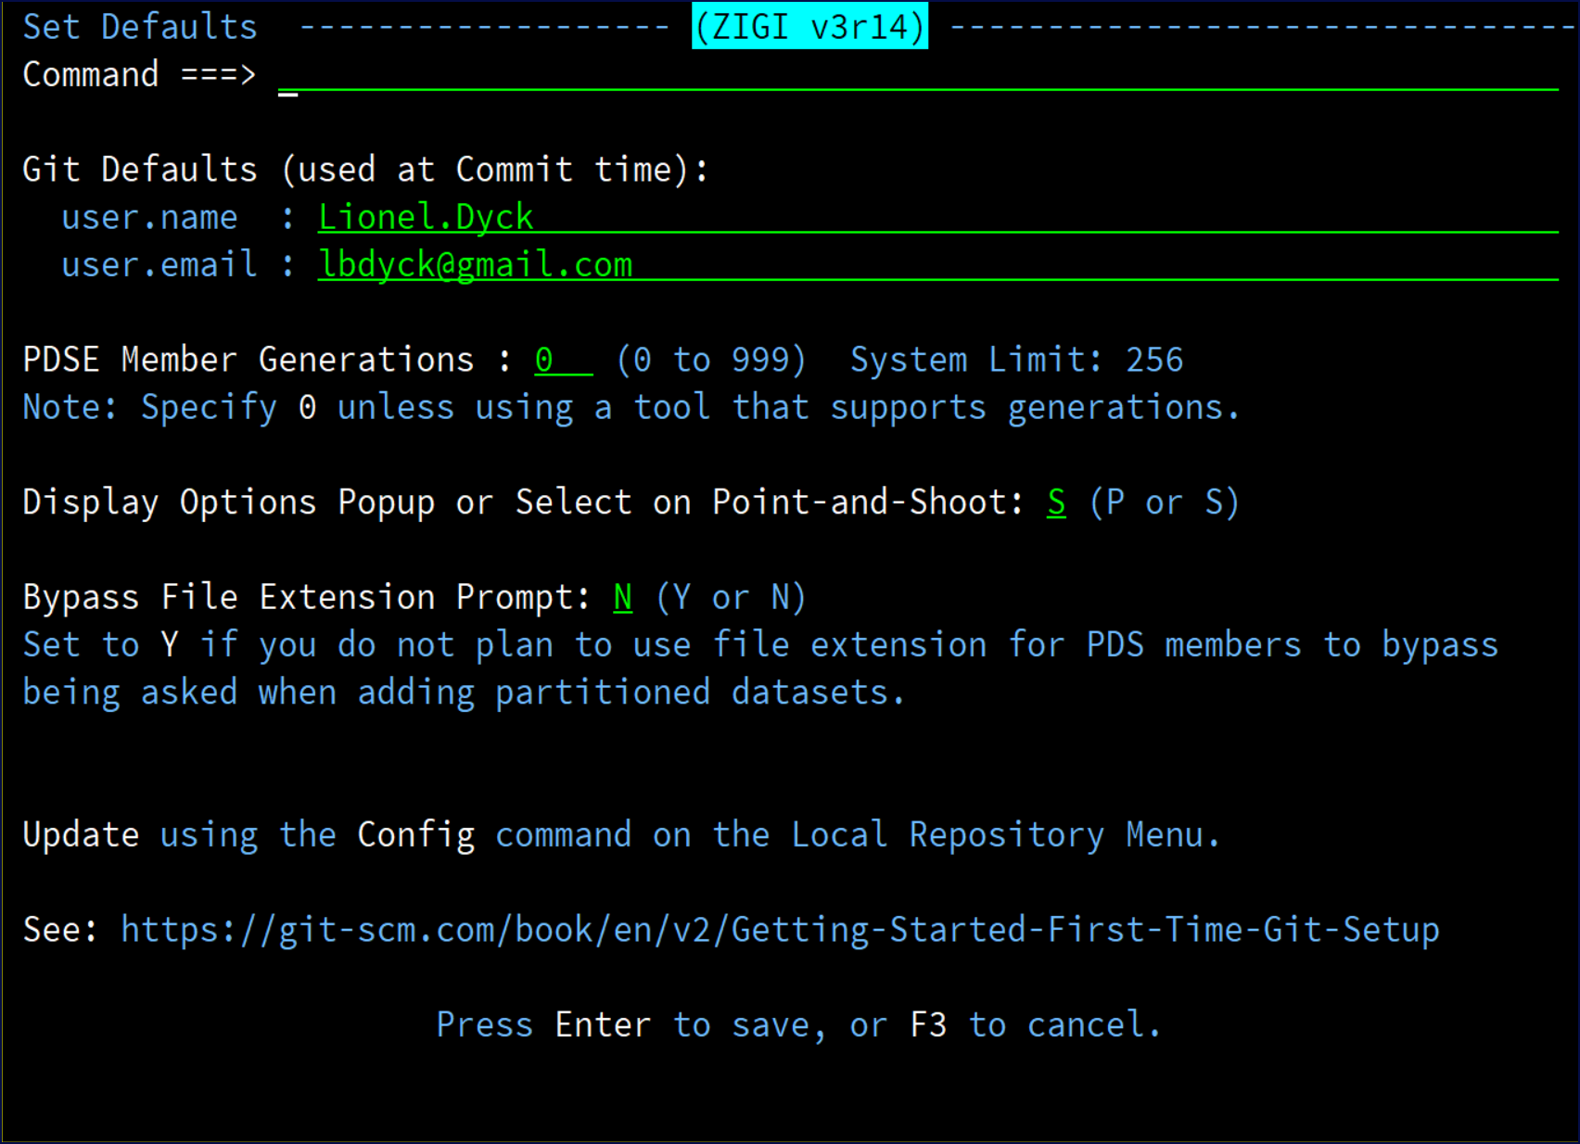

1. After providing your name and e-mail, if you haven’t created an SSH key pair yet, ZIGI creates this for you and shows you the public part of the keypair that you can add to your profile on GitHub (or BitBucket, GitLab, or your private enterprise Git server).

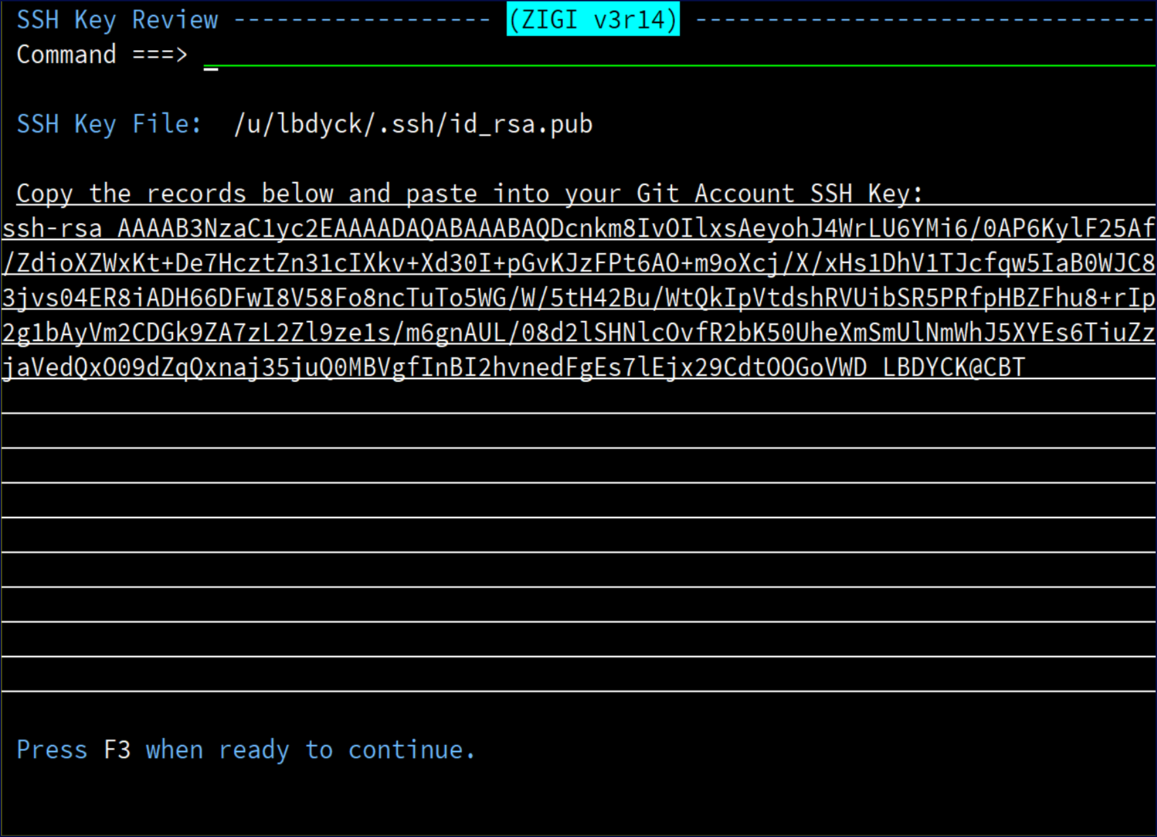

Note this is your public key and may be shared far and wide without concern as it is impossible to use without access to your private key, which you should never share.

1. Copy your SSH key and paste it into one of the following:

* GitHub settings
  1. Click on your icon, and then click **Settings**.
  2. Click **SSH and GPG keys**.
  3. Click **New SSH key**, enter a description, and then paste your SSH key.

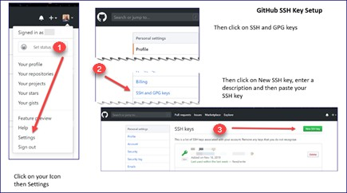

* BitBucket settings

1. Click on your icon.
2. Click **Bitbucket settings**.
3. Click **SSH keys**.
4. Click **Add key**, enter a title, and then paste your SSH key where directed.

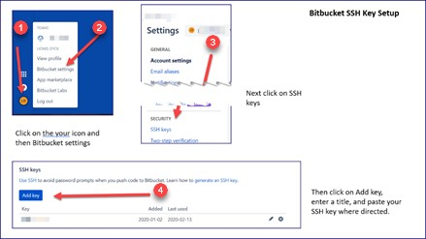

* GitLab settings

1. Click the User Settings icon in the upper right-hand corner.
2. From the drop-down menu, select **Settings**.
3. Click **SSH Keys**.
4. Paste your key, enter a title, and then click **Add key**.

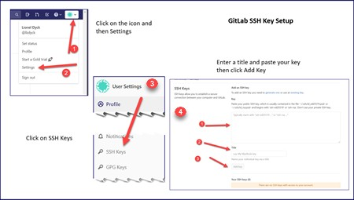

# ISPF Dialog Notes

This topic explains the various ISPF dialog notes you may see while using ZIGI.

Many of the ISPF panels support point-and-shoot for commands as well as row selections. This requires that your TN3270 emulator supports a double-click simulating the ENTER key if using the mouse for point-and-shoot. Alternatively, the cursor may be placed in the field or row, and the ENTER key pressed.

Changing the ISPF Settings to enable tab to point-and-shoot also proves useful. The point-and-shoot fields are underscored for easy identification.

The primary table display panels (Local Repository, Current Repository, PDS Member, and Tag List) support an ISPF action bar menu. This is in addition to the O command, which displays a pop-up menu of commands.

ISPF pop-ups are used to provide information to you at various points in the dialog where processing may not be instantaneous.

When starting ZIGI, the splash screen always displays. The splash screen can be disabled by entering a Y

to the Bypass option on the splash screen. This brings up the **zigi Status Popup**:

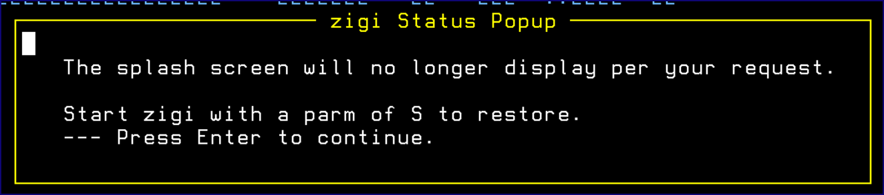

# The ZIGI Local Repositories Panel

This topic explains the components of the ZIGI **Local Repositories** panel.

After the preparatory work above, the main **Local Repositories** panel displays, which lists all of the local Git repositories that have been added to ZIGI:

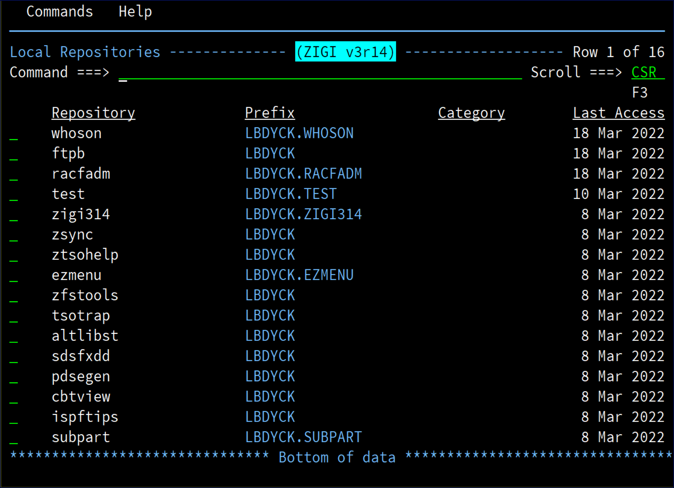

There are both commands and row selections available for use. The commands are available via the Action Bar menu and the row selections are available by entering a / in the row selection. This means you can move the cursor to them and press Enter or move the cursor there using your mouse and double- click with the left mouse button (this assumes your TN3270 emulator supports that feature; most do but you may have to enable it).

This chapter includes the following topics:

* Action Menu Bar
* Clone
* Config
* Connect
* Create
* GITHELP
* Options Menu Assist
* Select Command
* Sort Selections Pop-Up Menu
* SSH Public Key
* Row Selections

## Action Menu Bar

This topic explains the Commands and Help menus.

The action bar menus are there to make it easy to access commands when you forget, or want to use the mouse for point-and-shoot.

### The Repository Commands Menu

This topic provides a screenshot of the **Commands** menu.

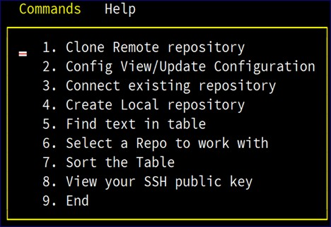

### The Help Menu

This topic provides a screenshot of the **Help** menu.

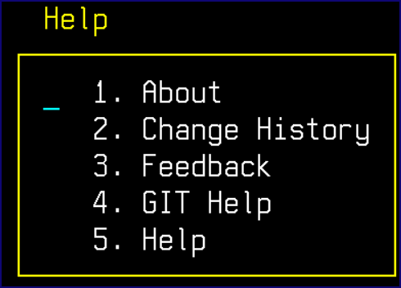

## Clone

This topic explains the clone repository functionality.

Clone makes a copy of a repository that resides on a remote server on your local OMVS filesystem and into a set of z/OS data sets based on a HLQ that you provide.

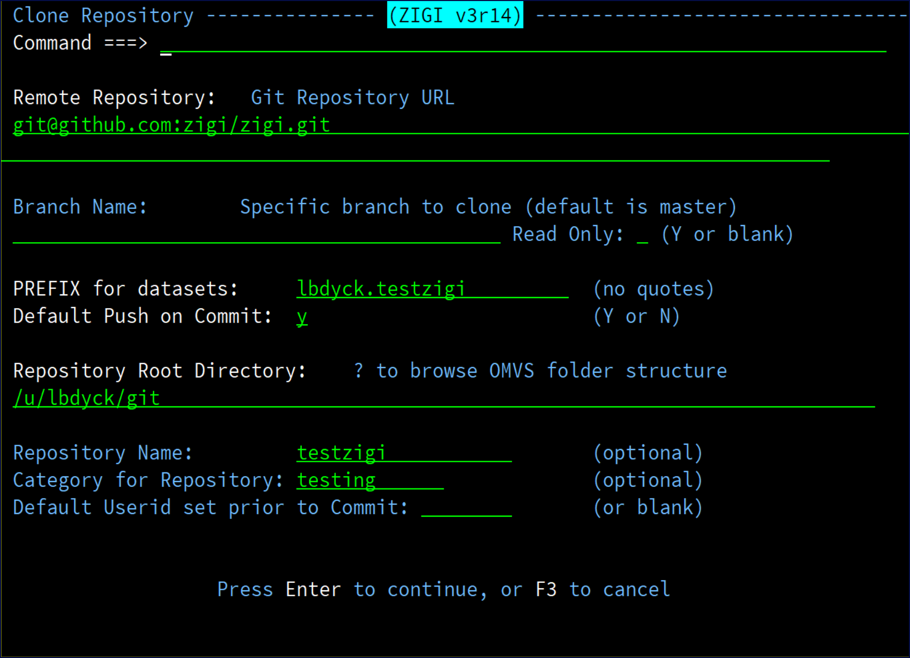

In the above example, the **Remote Repository** is the ZIGI repository on GitHub.

The authors have selected to enter the local OMVS directory manually, and the HLQ (prefix) for the z/OS data sets is specified.

If a ? is entered into the **Local dir** field, then a dialog is displayed to walk down the OMVS directories to find or make (MKDIR) the directory where the cloned repository is placed.

All fields except **Branch Name**, **Repository Name**, and **Category for Repository** are required fields.

The **Repository Name** defaults, if blank, to the Git name of the repository, otherwise the name is used for the local OMVS directory name for the clone operation.

The **Category for Repository** is helpful as a sort option on the Local Repository table display.

The **Default Push on Commit** option, if set to Y, is the default on the Commit panel to push after each commit.

The **Default Userid set prior to Commit** is set if there is a requirement to change the ISPF statistics userid for each PDS member before a commit. After the cloning is complete, the z/OS data sets in the repository are displayed.

This is also the panel that is displayed when the repository is selected from the primary panel.

If any existing z/OS data sets are about to be replaced by the clone operation, a display is presented during the clone process asking for permission with an option to change the data set prefix for the cloned data sets.

**Note:** ZIGI creates PDSE Version 2 libraries for all partitioned data sets with a default MAXGEN of 0 (see the Config command to change the default number of generation).

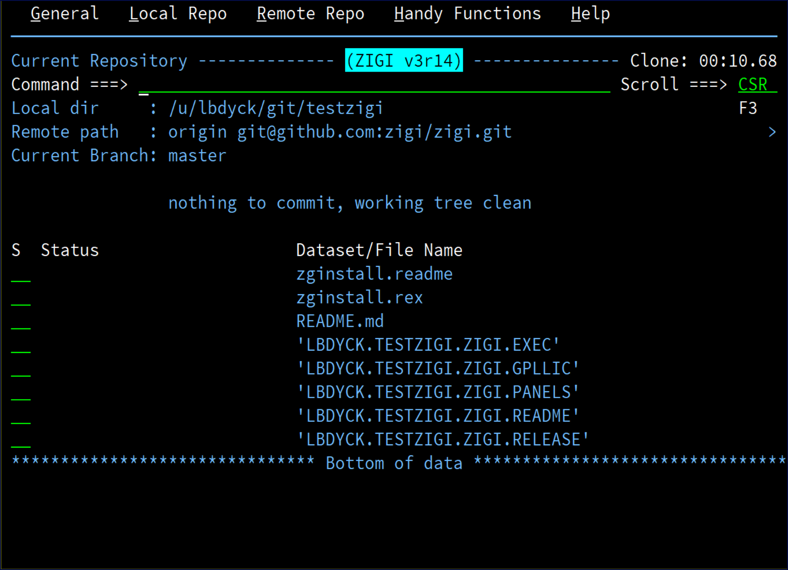

## Config

This topic explains the Config command.

This command allows you to view and update, if desired, your username and e-mail, the PDSE member generations default, and the display options pop-up.

Another option that is configured here is the option to bypass being asked if a file extension should be used for all members of the added PDS when the members are copied to the repository's OMVS filesystem.



In the future, this is also where other, user-customizable options can be configured. At this point, the **PDSE Member Generations** field should be 0 unless there is a tool available that can work with Member Generations (see [PDSEGEN](https://www.cbttape.org) for an open-source solution).

## Connect

This topic explains the Connect command.

The Connect command adds an existing local ZIGI-formatted Git repository to the ZIGI ISPF Table for ZIGI management.

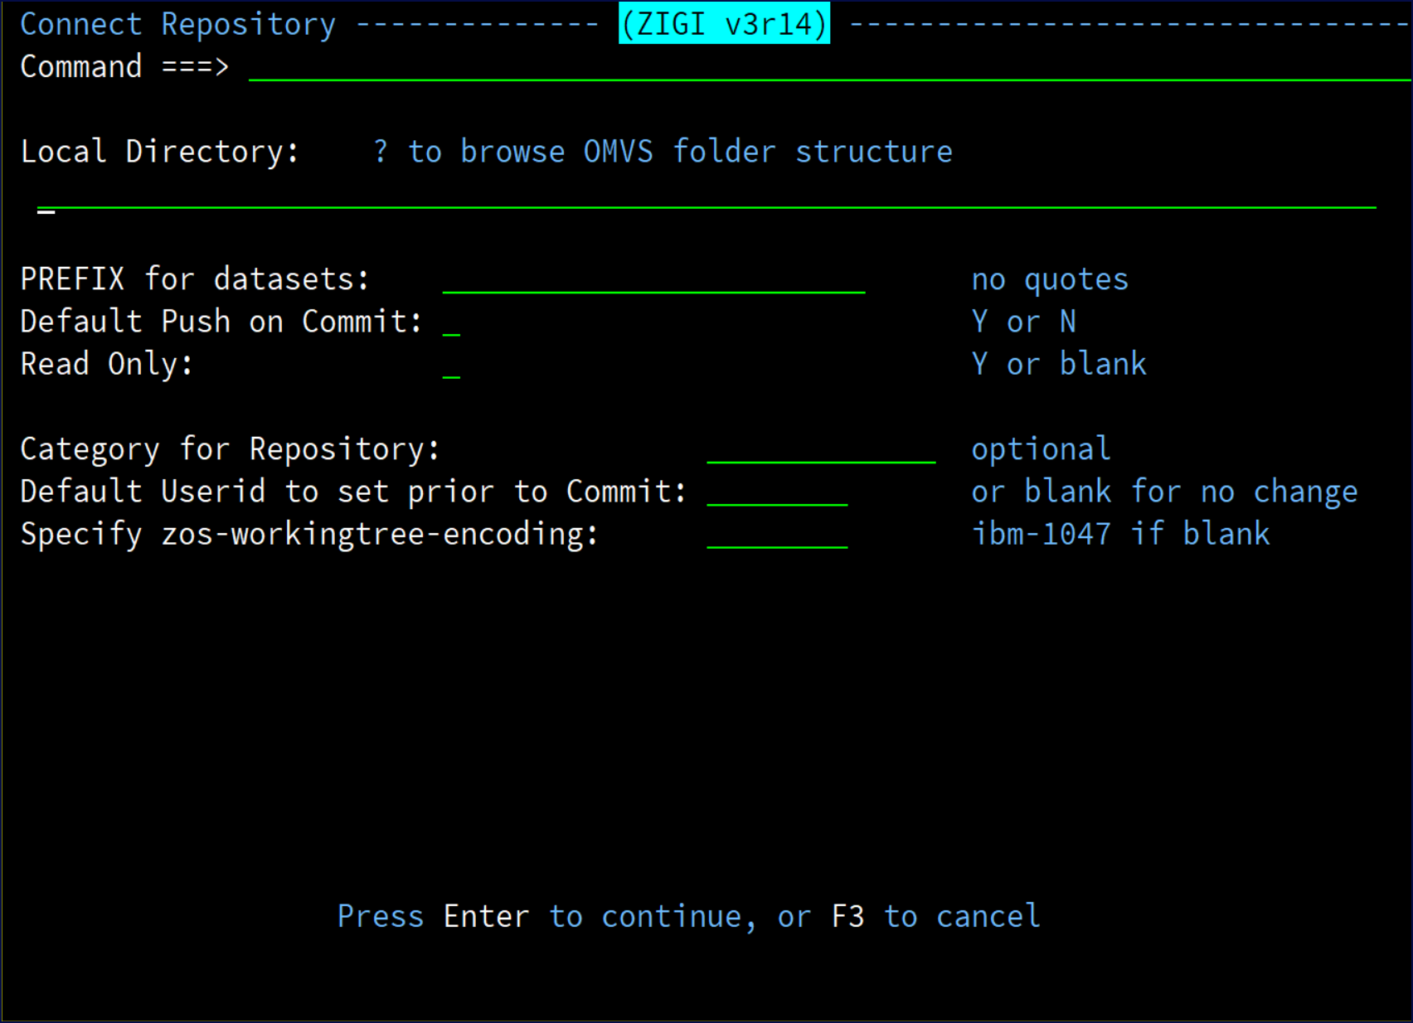

The local repository should point to the existing OMVS filesystem directory where the Git repository exists, and the repository must conform to ZIGI standards (with a .zigi subdirectory).

The other options are identical to the Clone and Create panels.

**Note:** The repository name is dynamically determined by the name of the repository directory.

## Create

This topic explains the Create command.

The Create command creates a new local repository that can be added to a remote repository.

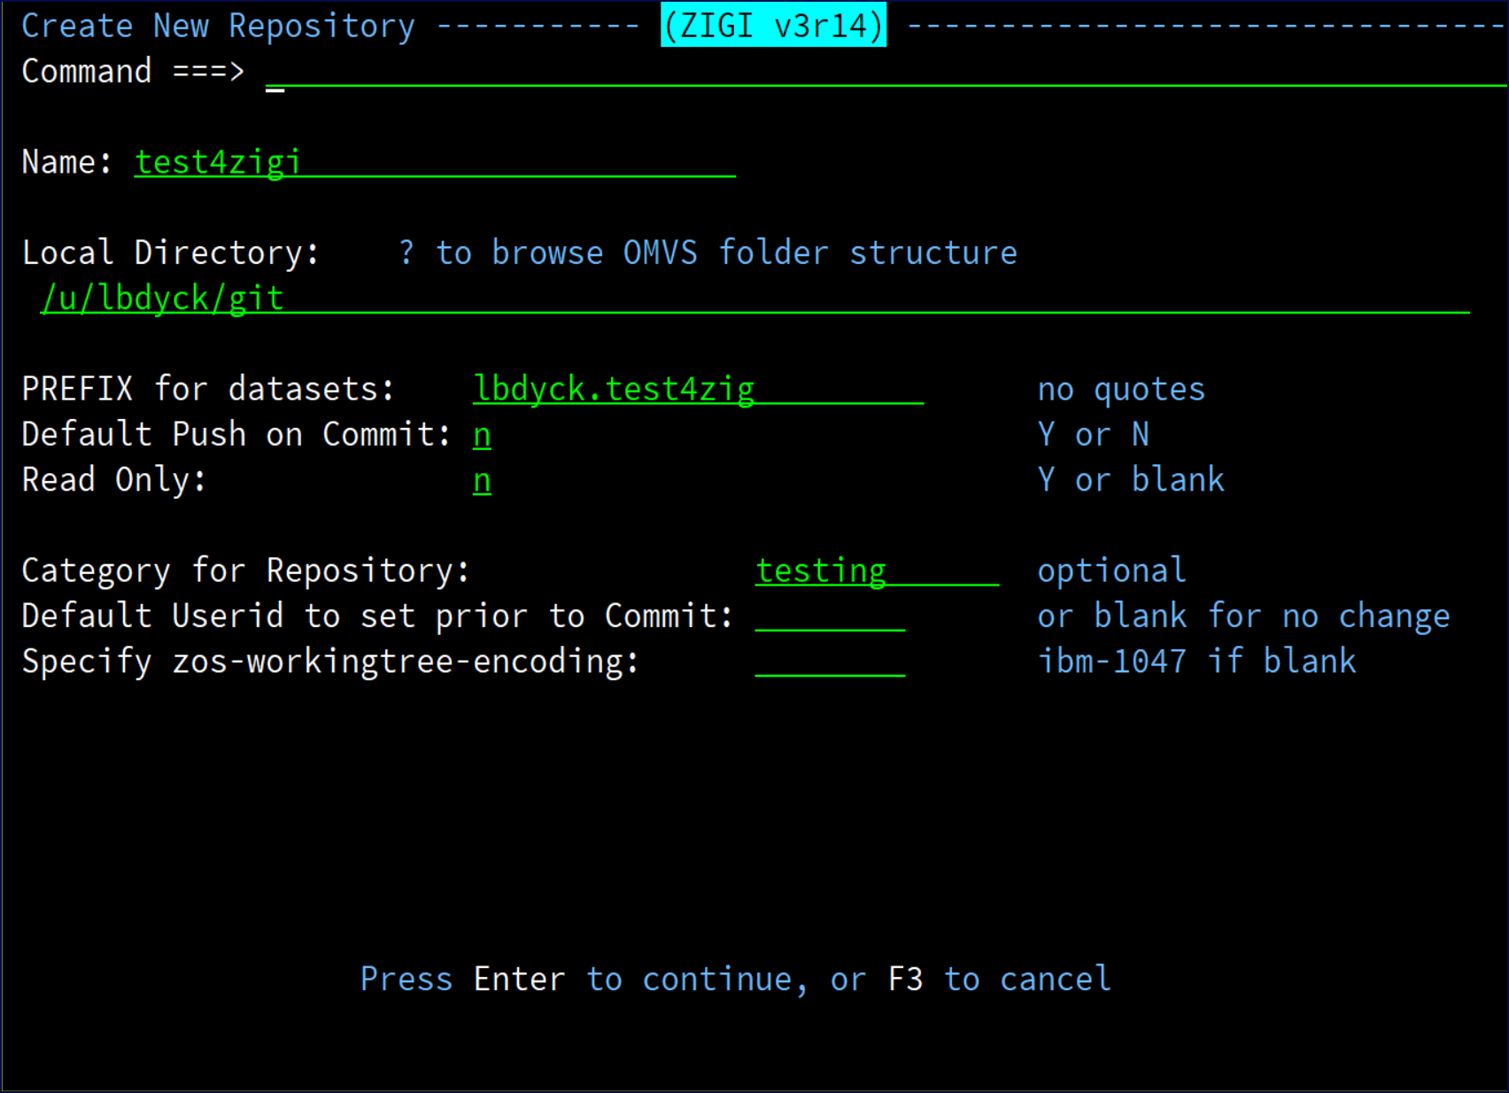

In the above example, a test repository is created in your test directory.

Using a ? in the **Local Directory** field brings up a file directory list from which a directory may be selected or created (MKDIR) and then selected.

The default push on commit option, if set to Y, is the default on the Commit panel to push after each commit. A read only repository is one in which the z/OS data sets are never updated by ZIGI and are intended to track changes to z/OS data sets. All changes are tracked by ZIGI and Git. All ZIGI features that could update or delete z/OS data sets are blocked. These repositories can be pushed to a Git server and then cloned; however, clone requires a data set prefix that should prevent a clone from replacing any existing z/OS data sets.

The **Category for Repository** is used for the ZIGI Local Repositories display to categorize the local repositories for sorting and easier identification.

The **Default Userid to set prior to Commit** is set if there is a requirement to change the ISPF statistics userid for each PDS member before a commit.

The encoding is the character set to be used for all data added to the repository. The default is ibm-1047.

The Read Only option creates a read-only repository. This repository is configured such that ZIGI does not allow any updates to the z/OS data sets from within ZIGI. This may be used for a shared local repository where several users access it for reference while preventing updates.

The repository may still be updated if the z/OS data sets are updated outside of ZIGI which causes ZIGI to update the OMVS files and thus the Git repository.

Edit, Merge, Branch, Replace, and any other ZIGI action that could update the z/OS data sets is prevented, but working outside of ZIGI does not prevent the updates from occurring.

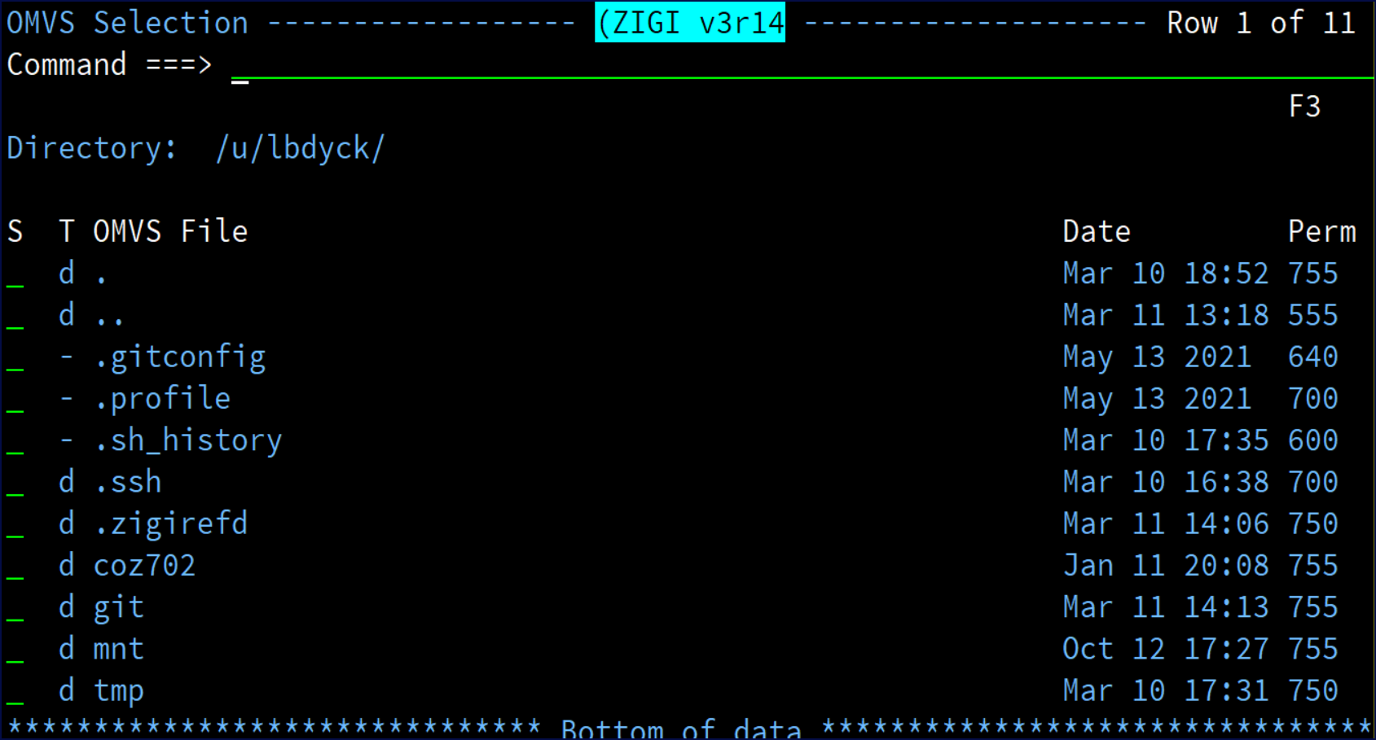

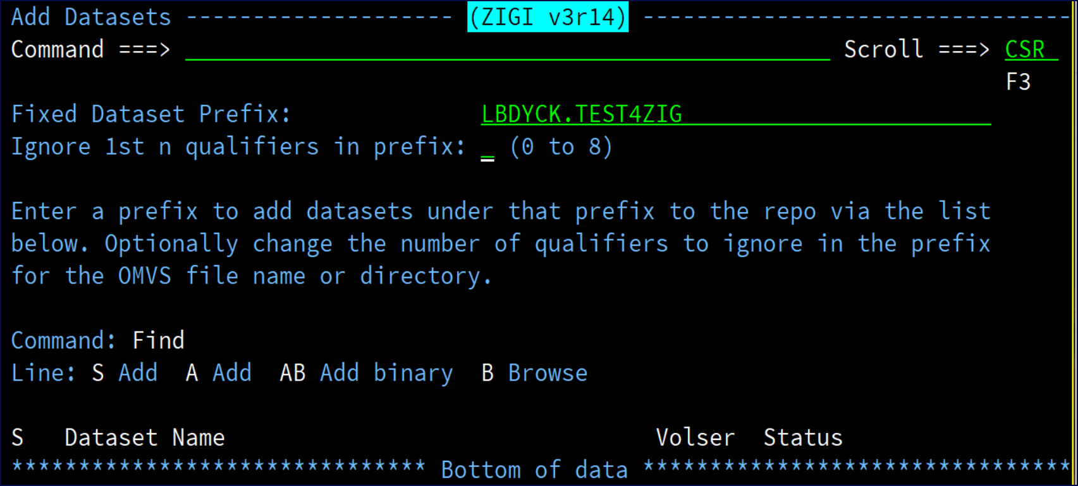

After the Create process completes, the **Add Datasets** panel displays to facilitate populating the repository with z/OS data sets:

This can also be achieved using the ADDDSN command to add existing z/OS data sets to the repository. See the AddDsn Command command, which is not to be confused with the add row selection, for more information.

## GITHELP

This topic explains the GITHELP ISPF dialog.

GITHELP is an ISPF dialog that provides simplified access to the Git help documentation. If you have a screen wider than 80 columns, then an alternate display is used where there is one row per command.

Syntax: GITHelp optional command (e.g., gith commit)

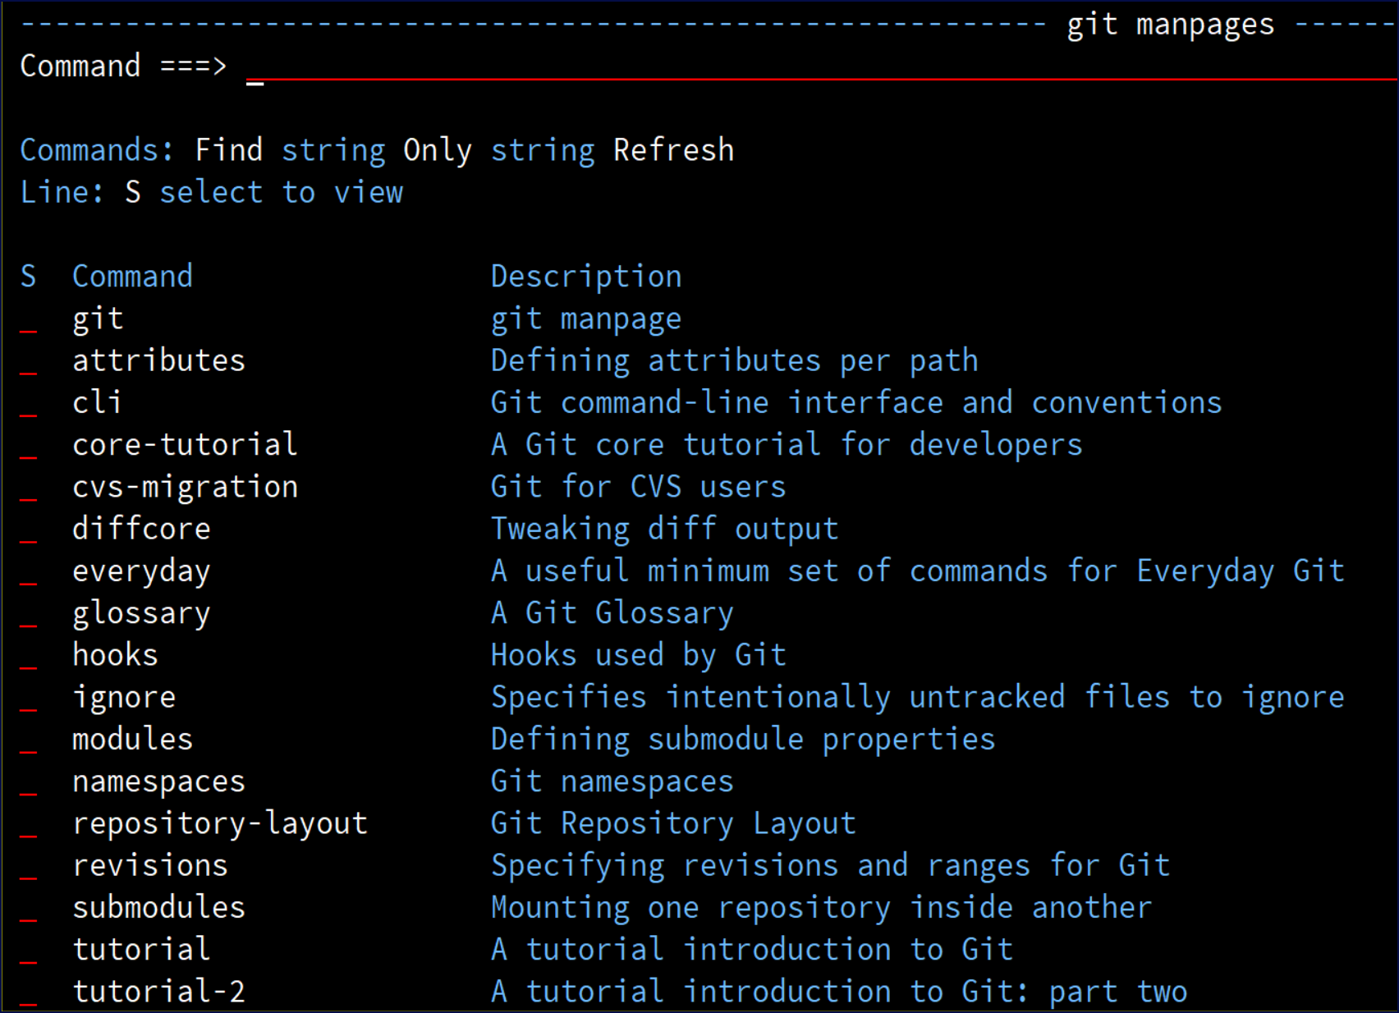

The Only command, entered with a string, limits the display of available commands to those that match the string in either the command name or the description.

Selecting a command displays the command's manpage:

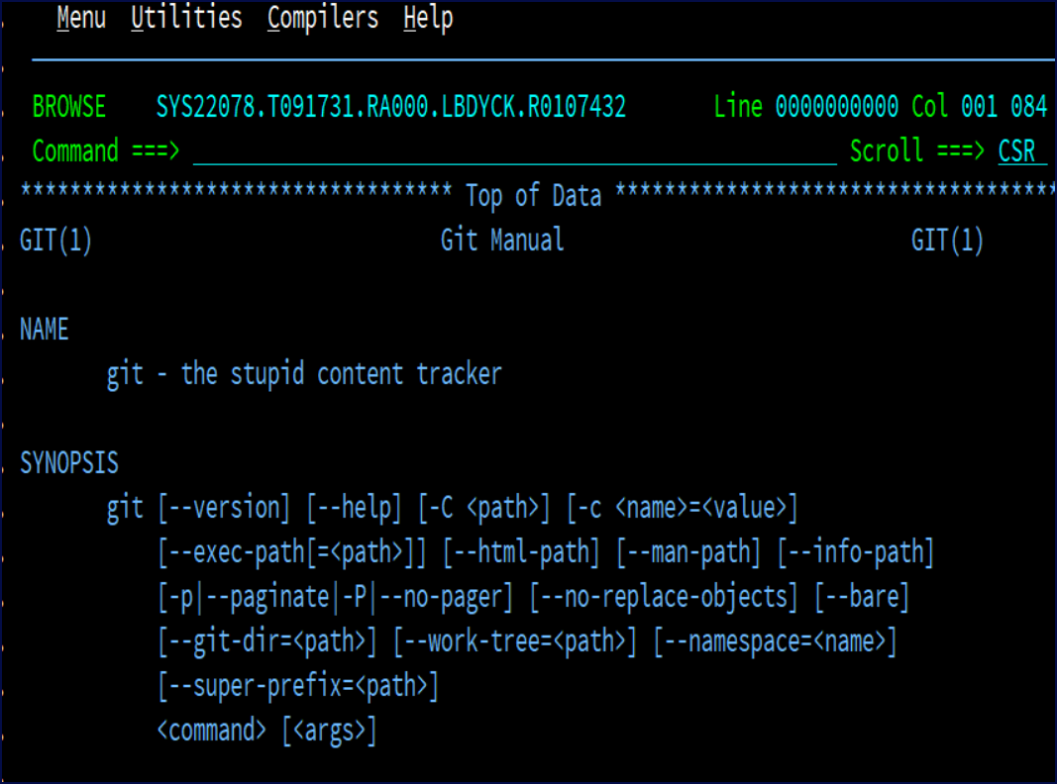

## Options Menu Assist

This topic explains the options menu assist pop-up menu.

Use O on the command line to bring up the **zigi Local Repository Commands** menu of all available commands. This is useful if you selected the Pro or Hidden menu.

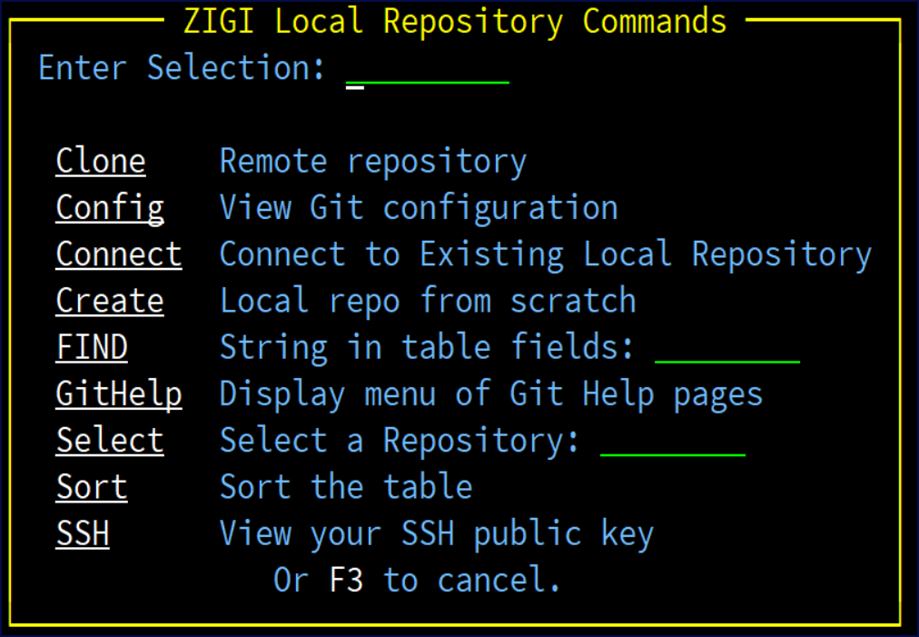

## Select Command

This topic explains the Select command.

There are several ways to select a repository to work with.

* The command line way is to enter Select repository-name on the command field.
* Tab to a row and press the Enter key.
* Place the cursor, using your mouse, on the row, and double click.

Syntax: Select *repository-name*

Select may be abbreviated as S and must be followed by the repository name.

**Tip:** For the Select command, the search is case insensitive.

## Sort Selections Pop-Up Menu

This topic explains the **zigi Sort Selections** pop-up menu. Sort the table based on the columns.

Syntax: Sort column1 order1 column2 order 2 Abbreviation of SO is allowed.

Sort column: **Repository** (R), **Prefix** (P), **Category** (C), or **Date** (D) Sort order: **Ascending** (A) or **Descending** (D)

If only the command SORT is entered, the **zigi Sort Selections** pop-up displays to assist.

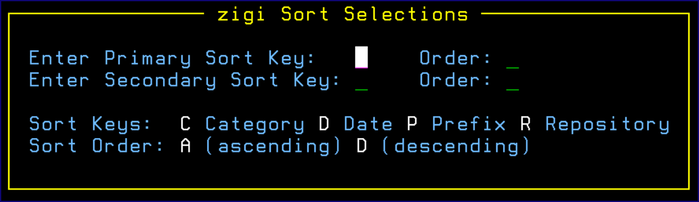

**Note:** The last sort order is retained and used the next time ZIGI starts.

**Tip:** Using Sort D D R A will sort the table with the last access date with the more recent on top and then sort the repository names in alphabetical order.

## SSH Public Key

This topic explains how to display your SSH public key.

This command displays your SSH public key so that it can be easily copied and then pasted into your GitHub (or equivalent) user profile settings to enable easy access to the remote repository. There is no concern about sharing your public key since it must be used in concert with your private key, which should never be shared with anyone.



## Row Selections

### Select Option

Selecting a repository using S (or point-and-shoot) opens the repository.

### Info Option

The info option displays a short summary of information about the repository.

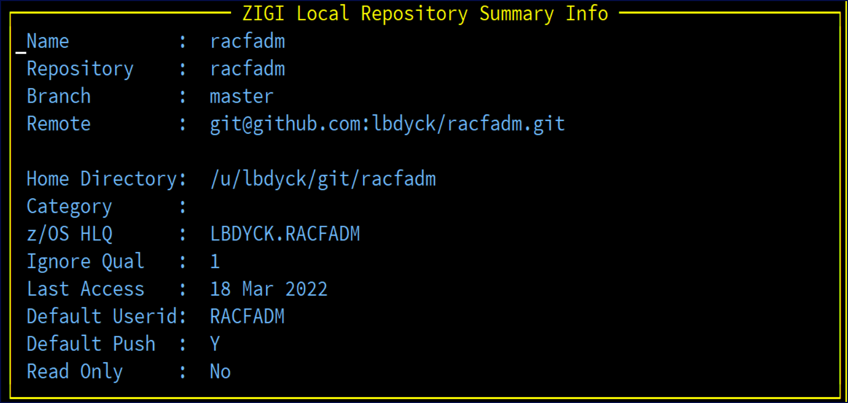

### View Option

Using View (v) opens the ISPF 3.17 (UDList) on the repository's OMVS filesystem.

### Delete Option

The Delete option removes the repository from ZIGI management by removing it from the ZIGI local repository ISPF Table. Options are provided to keep, or delete, the Git files, OMVS files, and z/OS data sets.

Confirmation on the **ZIGI Delete Confirmation** screen is required to proceed as a failsafe.

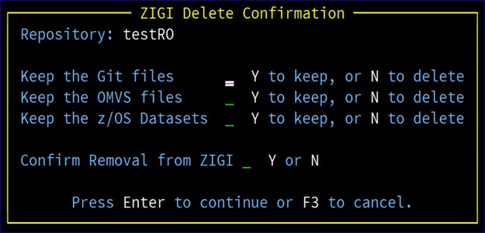

### / Row Selection Prompt

If / is entered for a row selection, the **zigi Local Repository Selections** menu displays to assist you:

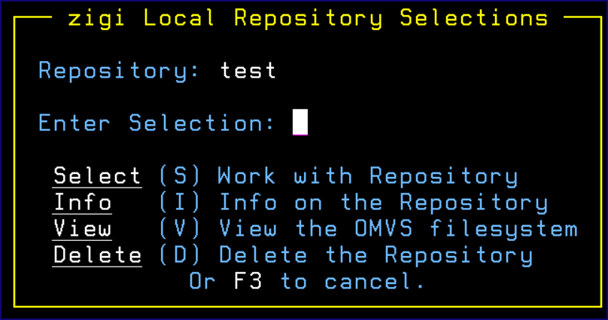

# The ZIGI Current Repository Panel

This topic explains the components of the ZIGI **Current Repository** panel.

When a repository is selected from the Local Repositories panel, the z/OS data sets associated with the repository are displayed:

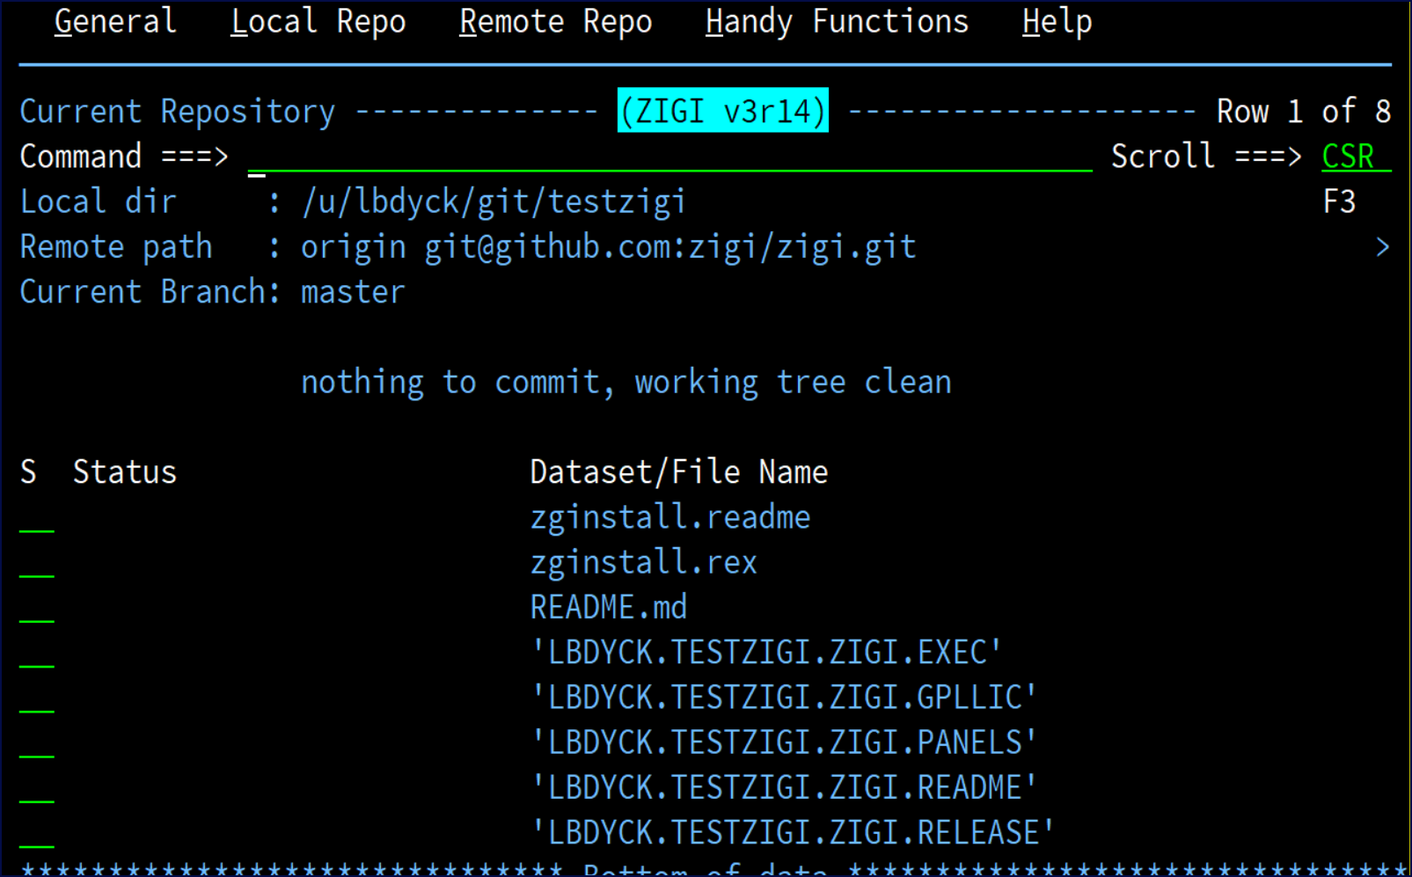

For demonstration purposes, this user guide uses the ZIGI repository to start with. This section includes the following topics:

* Action Bar Menus
* ADDall Command
* ADDDsn Command
* Branch Command
* Check Command
* Commit Command
* [Convert Repository (CONVREPO) Command](#_Convert_Repository_(CONVREPO))
* Diff Command
* Extract Command
* Flow Command
* GitCmd Command
* Git Help
* GitLog Command
* Grep Command
* Info Command
* Network
* Options Menu Assist
* Pull
* Push
* Readme
* Replace
* Remote Command
* Set Command
* Snapshot
* Stash
* [Stash List (STASHL) Command](#_Stash_List_(STASHL))
* Status Command
* Tag
* TagList
* View
* Row Selections

## Action Bar Menus

### The General Actions Menu

This topic provides a screenshot of the **General Actions** menu.

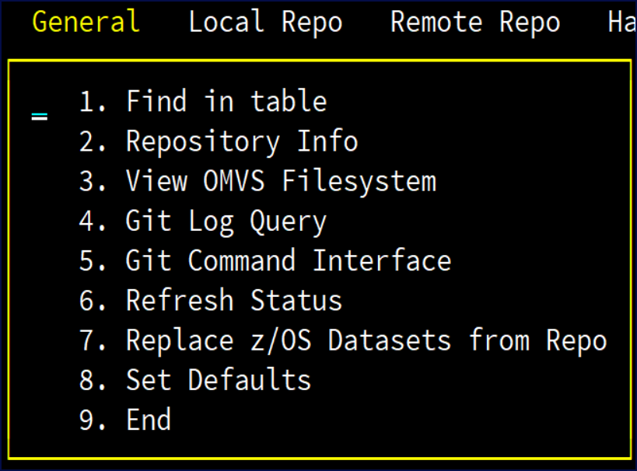

### The Local Repo Actions Menu

This topic provides a screenshot of the **Local Repo** actions menu.

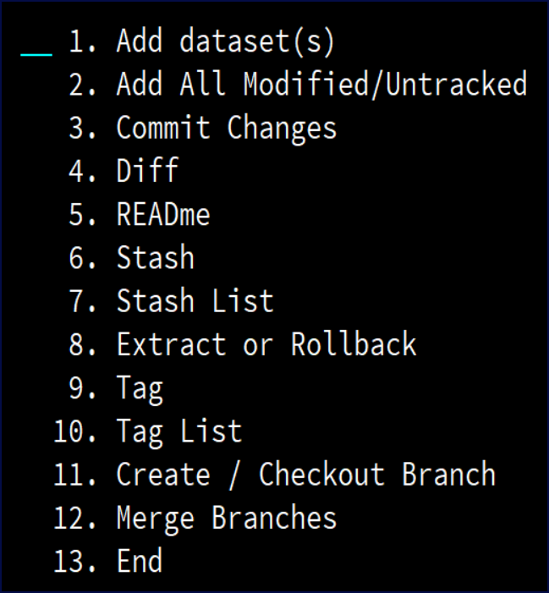

### The Remote Repo Actions Menu

This topic provides a screenshot of the **Remote Repo** actions menu.

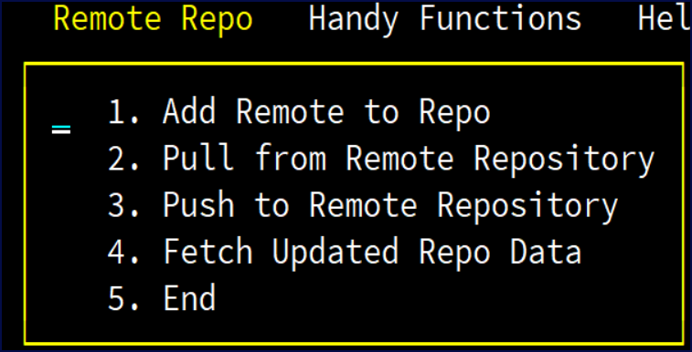

### The Handy Functions Actions Menu

This topic provides a screenshot of the **Handy Functions** action menu.

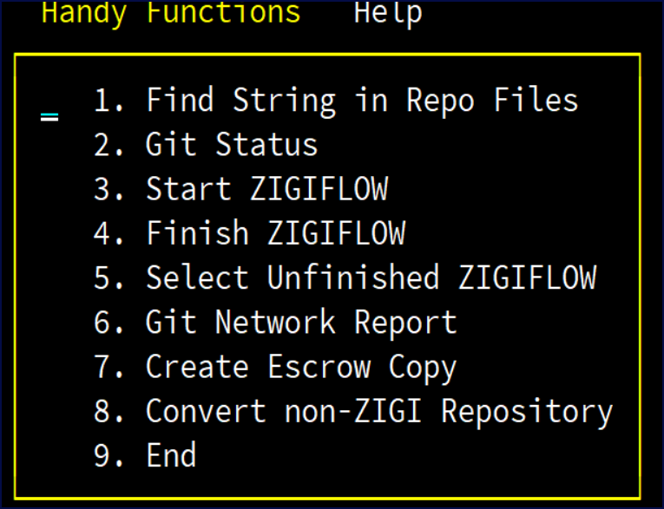

### The Help Actions Menu

## ADDall Command

This topic explains the functionality of the ADDall command.

The ADDall command adds all modified and untracked data sets and files to the Git staging index, which readies them for the next Git Commit.

Abbreviation: ADD

This is performed using the **git add .** command.

## ADDDsn Command

The ADDDsn command makes it easy to add additional z/OS data sets to the local repository.

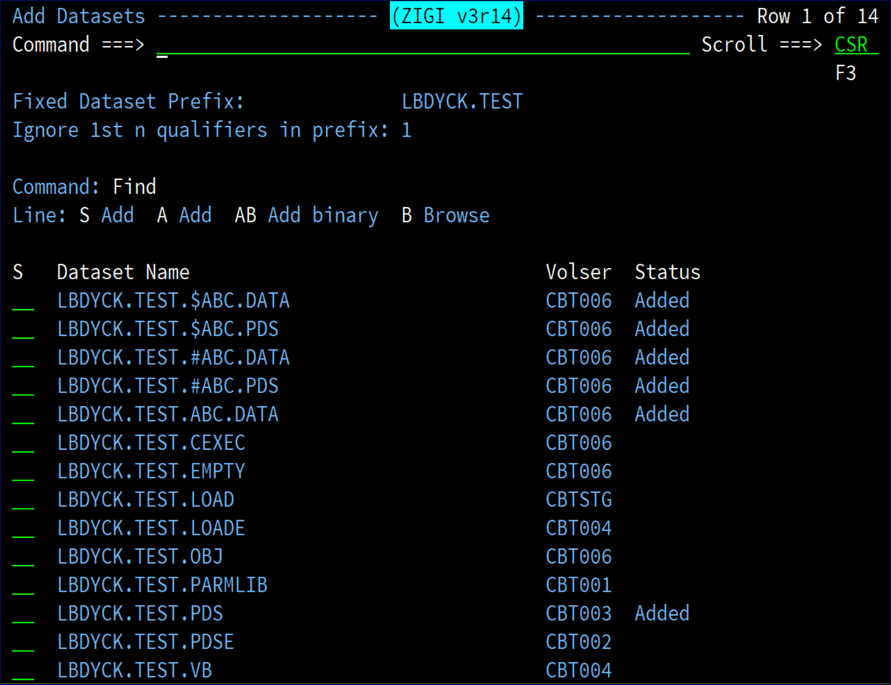

In the figure above, six data sets were already added to the local repository and others are available to add.

Note that only z/OS datasets that have been added will be managed by ZIGI as z/OS datasets. This adds an entry for the dataset into the .zigi/dsn control file. If a dataset is not included in .zigi/dsn then it will not be copied from z/OS to OMVS for git management, and if a file is in the OMVS filesystem, and managed by git, it will not be copied to a z/OS dataset unless it is found in the control file.

If the repository is new and there are no z/OS data sets included, then the **Fixed Dataset Prefix** and **Ignore 1st n qualifiers in prefix** are blank and must be filled in before the list of z/OS data sets may be presented. The qualifiers to ignore should be at least 1 but may be 0.

The **Fixed Dataset Prefix** field is the HLQ for the data sets to be presented, from which one, or more, may be added to the repository. Be aware that adding a binary data set using the A or S option adds the data set as text data and not binary. If the data set contains binary data, then add it using the AB (add binary) option.

If the data set is a load library (RECFM=U), then it is added as binary and as an executable load module regardless of the selection (S, A, AB). If there are aliases associated with any load module, then those are retained as well in the copy operation from z/OS to OMVS and restored in the OMVS to z/OS copy.

The **Ignore 1st n qualifiers in the prefix** field instructs ZIGI to ignore those qualifiers when creating the OMVS file, or directory, for the data set. Thus GITUSER.ZIGI.ZIGI.README is created in the OMVS filesystem as ZIGI.README. Then when someone else clones this repository, the file is uploaded using

the HLQ that they provide, which results in a z/OS data set of hlq.ZIGI.README. Make sure that the ignore count does not exceed the number of qualifiers of the data set you want to add.

To clarify:

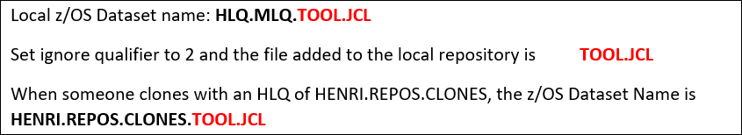

When adding a PDS, you are prompted to enter an optional file extension to be used when copying the PDS members to the OMVS filesystem. This enables the use of workstation clients to clone and update a repository by using the file extensions to easily identify the language type within the workstation editors (for example: source.c instead of SOURCE). If the optional extension is not provided, then the member names continue to be copied in uppercase to the OMVS filesystem without any file extensions.

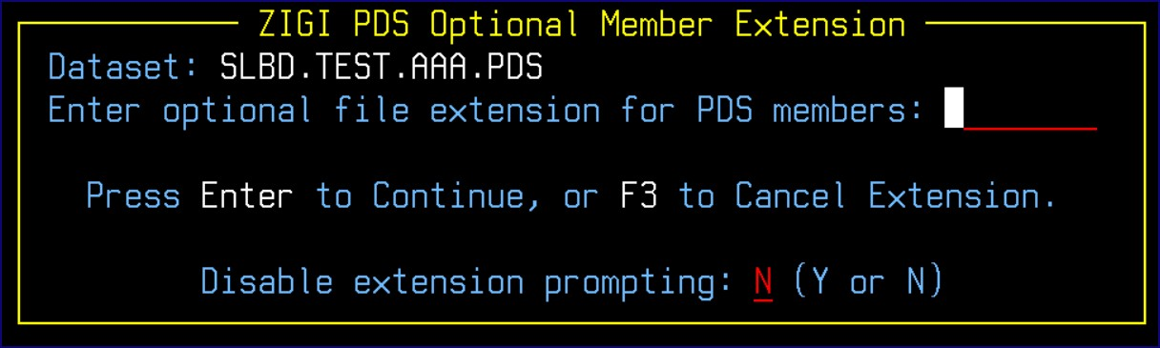

There is a restriction that only one file extension is allowed per PDS. This restriction is in place to prevent member name collisions from two files with the same file name but different file extensions (for example: source.c and source.jcl). This prompt may be disabled for the current set of adds by entering a Y to disable.

**Note:** The **ZIGI PDS Optional Member Extension** prompt may be bypassed by setting the bypass option to Y (yes) on the config settings panel from the **Local Repository** panel.

### Select (S) and Add (A) Commands

The Select (S) and Add (A) selections add the data set as text data, or if RECFM=U, as a binary executable that includes tagging the file as binary and updating the .gitattributes file accordingly.

### Add Binary (AB) Function

The Add Binary (AB) function adds the entire data set as binary data. This includes tagging the OMVS copy of the data set with the binary tag (chtag) and updating the .gitattributes file. If the data set is a PDS that contains both text and binary members: S or A the entire data set, select the PDS from the **Current Repository** panel, and then from the Member list AB the individual members that are in binary format.

### Browse (B)

Browse (B) allows you to verify the data before adding it using ISPF Browse.

## Branch Command

The Branch command allows you to change to a different repository. If the branch does not exist, you may create it (effectively performing a checkout -b). If it exists, you may check out that branch with the C line command.

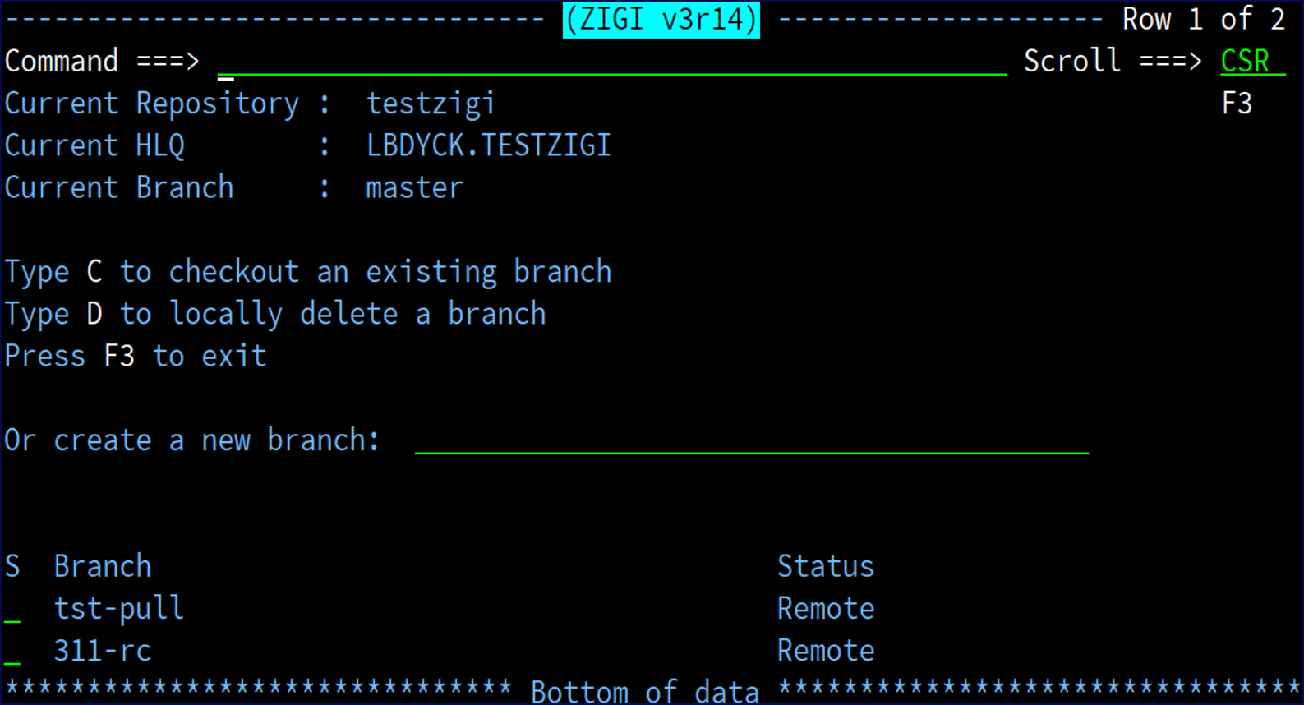

**Note:** The **Status** column indicates if the branch is only on the **Remote** server, or if there is a local copy (**Local/Remote**).

## Check Command

The Check command checks all z/OS data sets, based on the last reference date from the data set control block (DSCB), to determine if the data has changed since the repository was opened. This is useful if the repository has been open for a period of time and the repository's data sets have been updated outside of ZIGI and may be easier than exiting the Repository and selecting it again.

## Commit Command

The Commit command commits the current set of changes that have been added to the Git index to the local repository. Optionally a git **add** can be invoked prior to the Commit using this dialog. This does not push the updates to the remote repository unless the **Push after** field is set to Y.

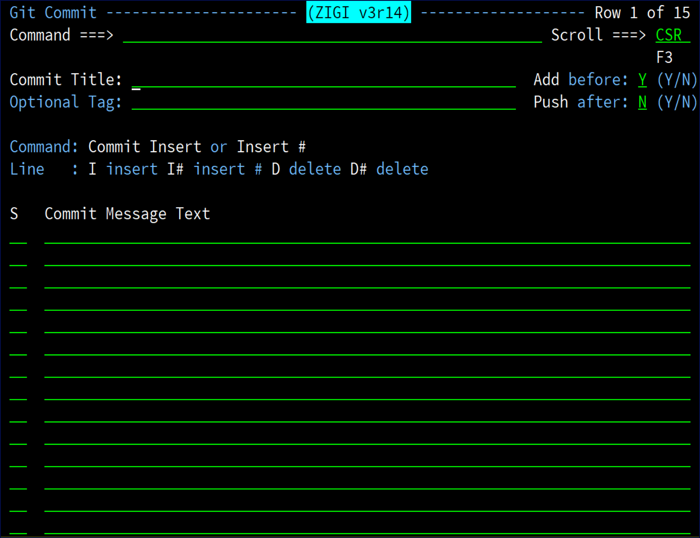

1. Enter a title, which is limited to 44 characters, that summarizes the changes being committed.
2. Enter as many lines of text as required. Initially 15 lines are available for text entry; however, more can be inserted using the Insert command (for example: I 10) or the line command I (for example: I 9).
3. A line may be deleted using the delete (D) line command.
4. Optionally, entering a Tag generates a git tag command to tag the repository.
5. Enter Commit on the command line to process the commit or use the F3 key and reply Commit.

## Convert Repository (CONVREPO) Command

The convert repository (CONVREPO) command converts a repository that has been cloned into your OMVS filesystem into a repository that ZIGI can manage. There are numerous requirements for ZIGI to manage a repository, primarily because Git has no awareness of the z/OS data sets. All Git files are stored in an OMVS filesystem.

A ZIGI-managed repository requires the following:

* A .zigi directory in the repository root directory.
* A file with the name of dsn in the .zigi directory with information on the z/OS data sets managed by ZIGI:

# Default DSORG and DCB info

* PO FB 80 32720

SAMPLE.REXX PO VB 255 32760

SAMPLE.PDS PO FB 80 32760

SAMPLE.TEXT PS FB 121 27951

* Each z/OS sequential data set must have a copy in the repository root directory.
* Each z/OS partitioned data set must have a directory in the repository root.
* Each PDS member must have a copy in the directory associated with the full PDS.
* Only files that are uppercase and conform to z/OS data set naming conventions are accepted by ZIGI to be copied to z/OS.

The conversion process:

1. Creates a .gitattributes file in the repository root directory if one does not exist. If a .gitattributes exists in the repository then it is untouched, but you should consider updating it with some of the .gitattributes that you can find in ZIGI managed repositories.
2. Creates a .zigi subdirectory.
3. Creates a .zigi/dsn file with a set of defaults.
4. Identifies files in the repository root that conform to z/OS data set naming conventions, after being translated to uppercase, and copies them to z/OS data sets using the HLQ defined when the repository was cloned.
5. Identifies directories in the repository root that conform to z/OS data set naming conventions after being translated to uppercase.
   1. Creates a PDS in z/OS.
   2. Renames the members within to remove any suffix to files with uppercase names assuming the file conforms to z/OS PDS member naming conventions.
   3. Copies renamed files to the PDS as members.
6. Files that end with .bin are treated as binary files and the .bin suffix is removed when copied to z/OS.

**Note:** This is provided for those who would like to use it but it does not work with many non-ZIGI format repositories.

## Diff Command

The Diff command will display the pending changes prior to staging (add) or pending changes prior to a commit.

The syntax is:

Diff (to be prompted)

Diff 1 (for prior to staging)

Diff 2 (for prior to commit)

The prompting panel is:

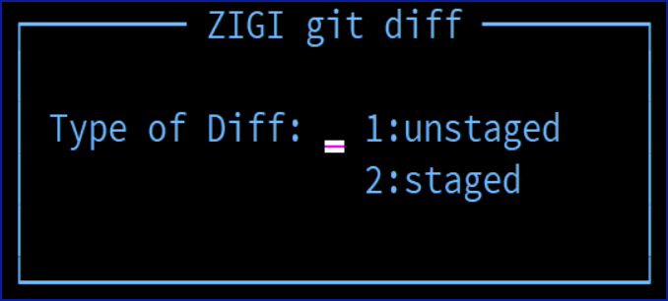

## Extract Command

The **Repository Extract** screen provides you with several options working within the current repository. The extract selection display is:

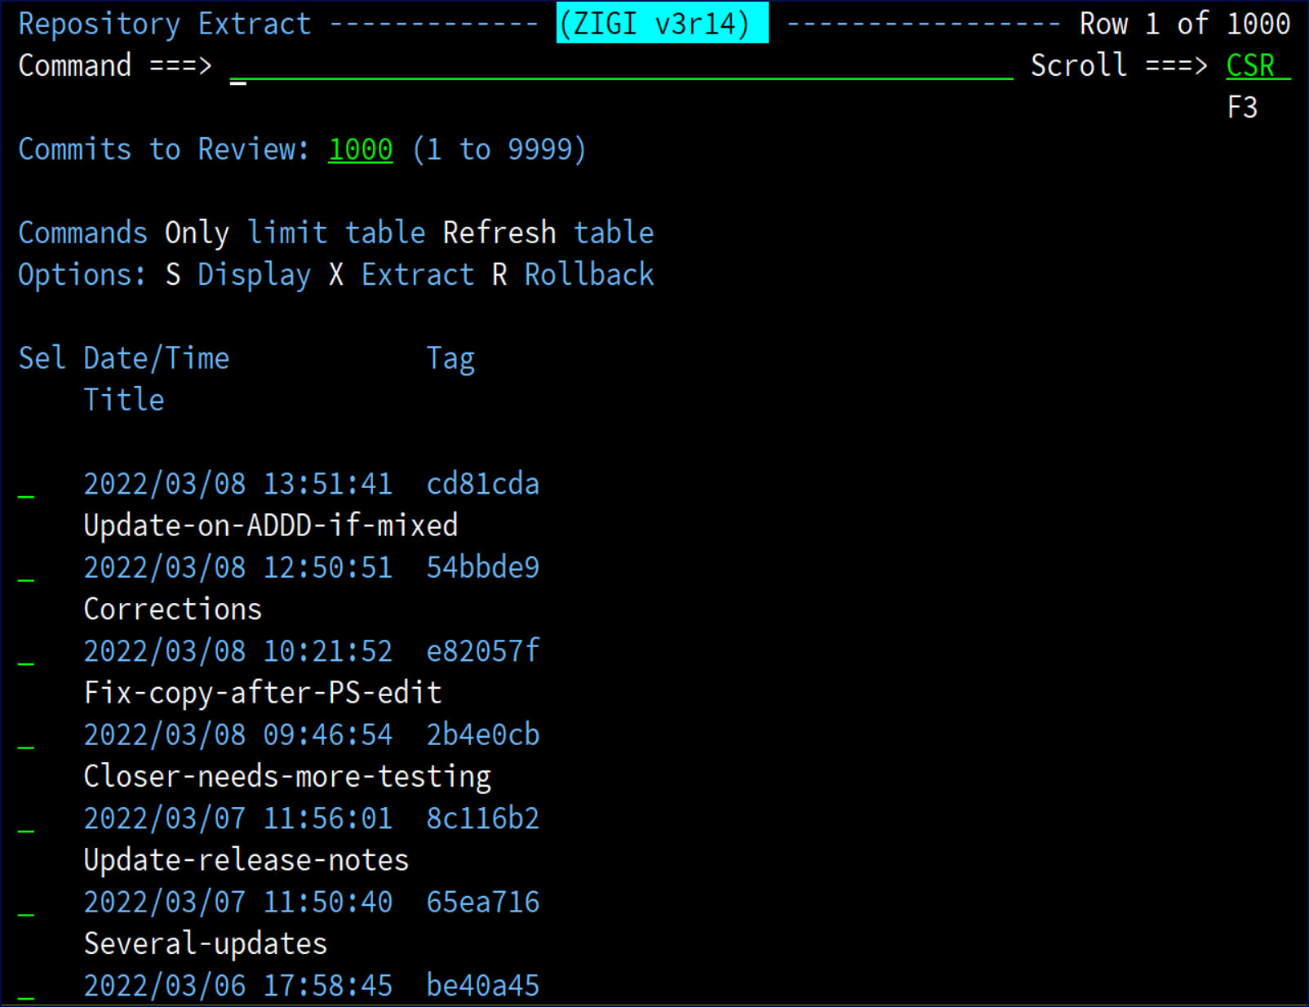

Use ONLY (O) followed by a short string to limit the display of items to those that match the string in the commit title.

Use REFRESH (R) to restore the full display. Select (S) the individual commit to view it:

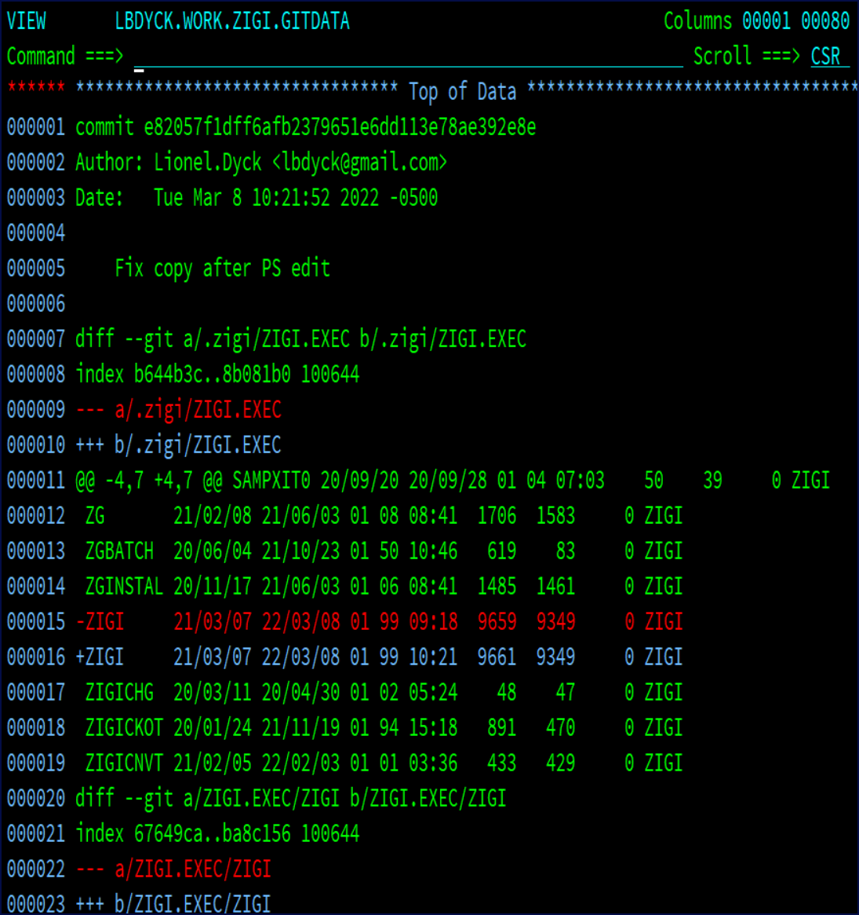

Or select using R to Rollback to that commit level:

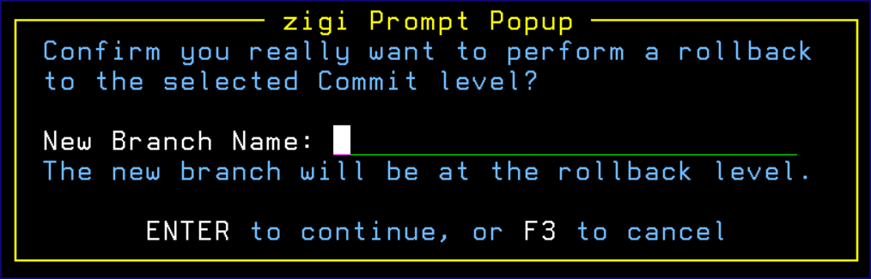

The **zigi Prompt Popup** requires the name of a new branch and that the word ROLLBACK be entered in uppercase letters to confirm that you want to do it.

Option X is used to extract all the changed elements from all the selected commits into a set of non-Git managed data sets and OMVS directory. This can be used for packaging to distribute changes to others (for example: create a PTF). When multiple commits are selected, all changed elements from all selected commits is collected, then the most recent commit level is checked out to a temporary branch from which the changed elements are copied from.

The **ZIGI Extract Prompt** displays:

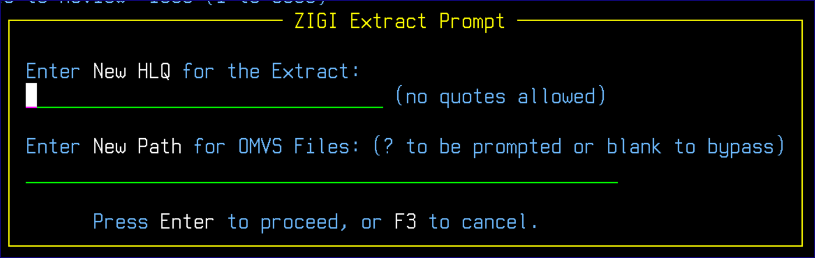

Enter an HLQ for the extracted z/OS data sets and an optional OMVS directory (must not currently exist as it is created) into which the changed elements are copied.

## Flow Command

To assist you in your workflow, ZIGI helps you via the ZIGI flow commands. The FLOW command displays the **zigi Flow Menu**:

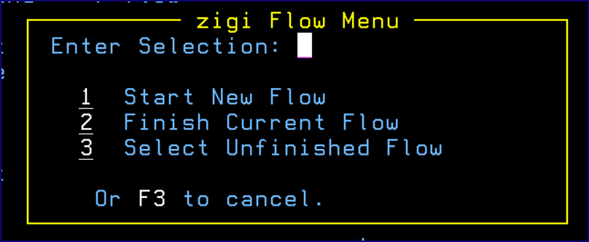

The **Handy Functions** action bar menu is similar:

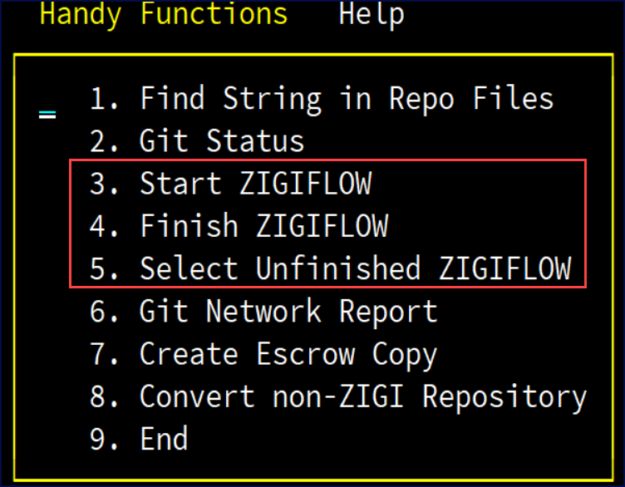

A new ZIGI flow can be started at any time if the workspace is clean. In other words, there can be no local changes that are not committed to the current branch.

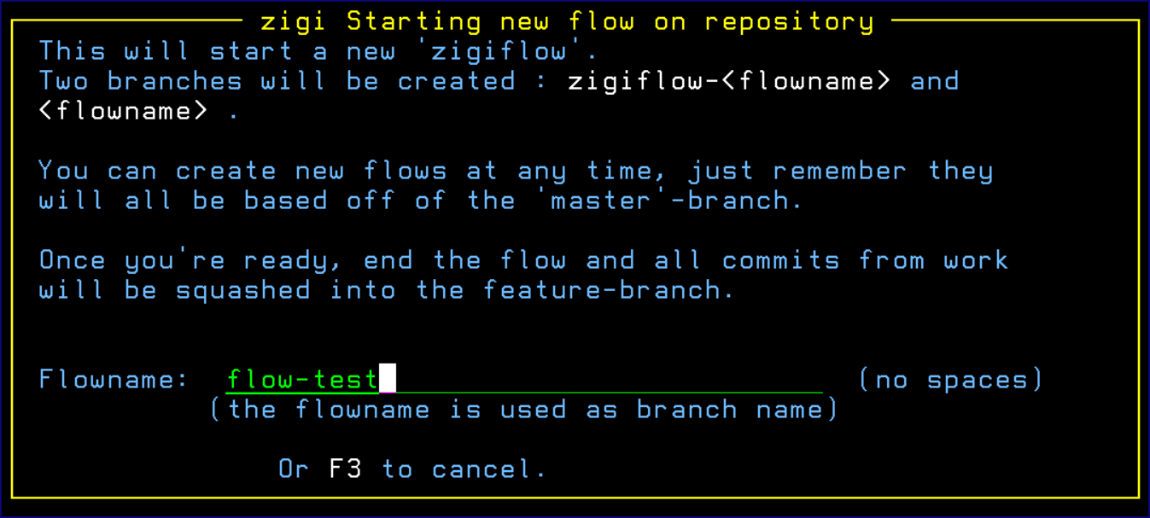

When starting a new ZIGI flow, ZIGI prompts you for a flow name. This is used internally as a branch name so spaces are not allowed.

Upon starting a flow, ZIGI checks out the master branch, create a new branch called

zigiflow-*yourFlowName*, and also creates a *yourFlowName* branch. Both of these branches are identical to master.

Then you can make changes, commit, and once done, finish the flow. Upon finishing the flow, all the commits from the zigiflow branch are squashed into the final branch at which point this can be merged into the master or pushed out to a remote repository so a pull request might be issued.

Due to the way zigiflow manages the internal branching, it’s easy for you to (once the workspace for their current work is clean,for example: work-in-progress is committed to the flowbranch) start another zigiflow (always based on master) to perform some efixing. Once that flow is done, the resulting branch can be merged to master (or pushed for a pull request) and also be merged into the other workflow.

Switching between workflows is done via option 3 and can only be done in a clean workspace.

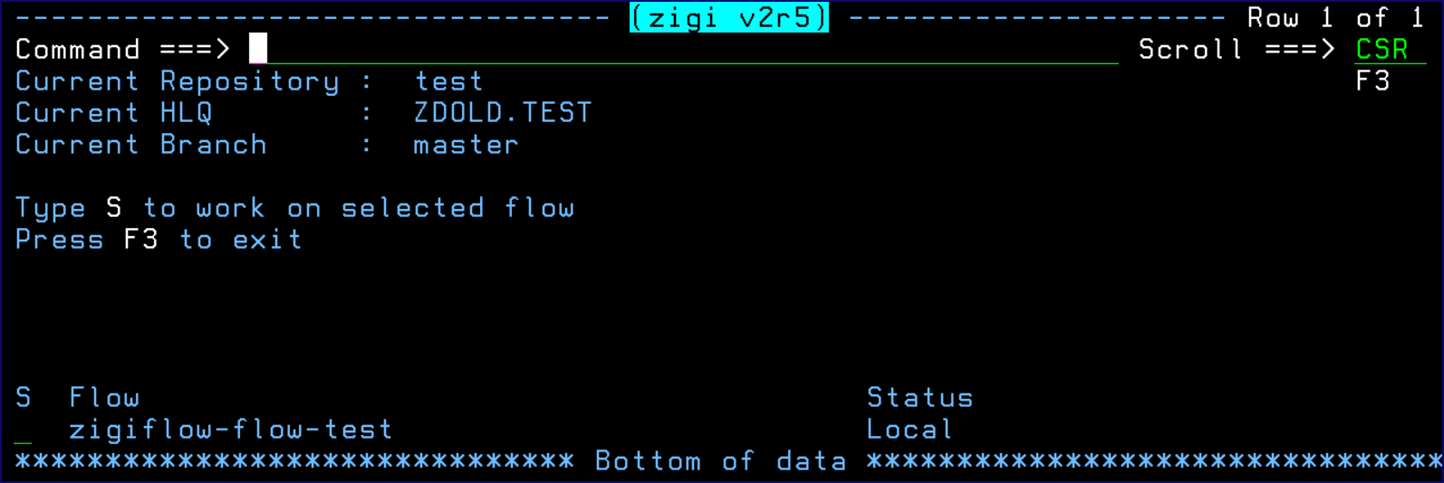

## GITCmd Command

This topic explains the functionality of the GitCmd command.

Git Command is an ISPF dialog, similar to ISPF Option 6, which makes it easy to enter Git commands from within ZIGI, assuming there is something you want to do that ZIGI doesn’t already do.

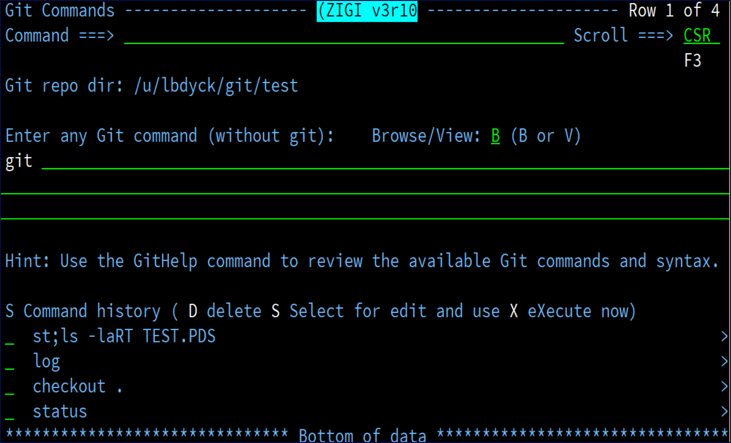

The dialog displays better in a wide screen; however, if using a standard 80 column display then the command history fields are scrollable (as indicated by the **>** symbol on the right side of the screen).

Any Git command may be entered and it is remembered the first time it is used. The history is a push-down stack of previous commands from which you can delete a command you no longer want to keep, select a command to be placed into the command entry field where it can be tailored and executed, or execute a command and have it placed into the command entry field after execution.

The results of all commands are displayed using ISPF Browse or View, depending upon the selection.

**Note:** Git is already in the command, so you do not have to enter it in the command entry field.

The CLEAR command is available to clear out the table or individual commands in the table may be removed using the D selection option.

The Git command table is shared among all repositories.

To execute multiple commands, including OMVS commands, string them together using &&. See the following figure for an example:

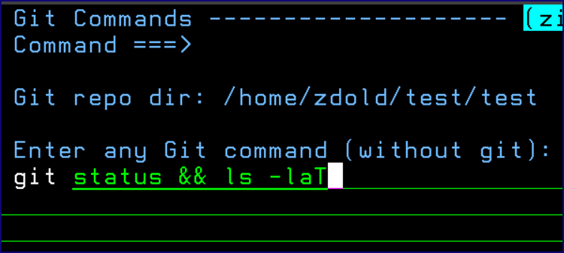

## Git Help

See GITHELP for more information.

## GitLog Command

This command displays the Git log information. When requested, the **zigi Log Filter** pop-up is presented to request the amount of log information to report:

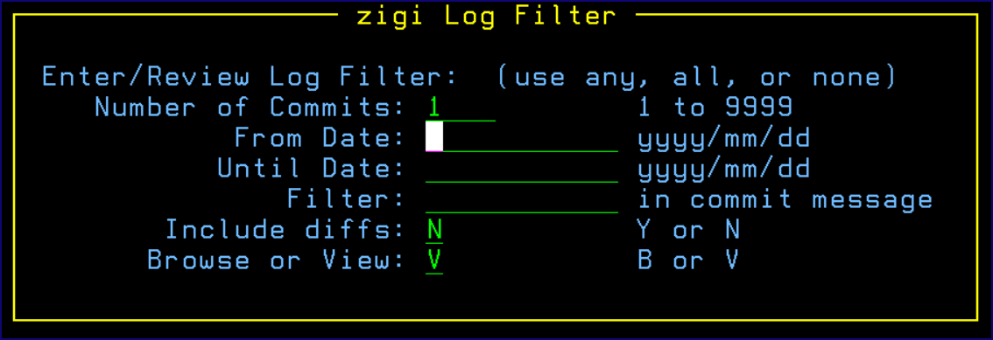

**Note:** The date format is yyyy/mm/dd, which is translated to yyyy-mm-dd and is required by Git. The reason for this is that we are using the ISPF Panel verify for standard dates to verify the date.

The Filter is a string that is used by grep to filter commits to that string. No blanks allowed. The values entered are remembered in your ISPF Profile for repeated use. The Git log command is executed using the

--cc and -m options along with the appropriate options for the above values, after which the ISPF view (or browse – no special colors with browse) is invoked on the results:

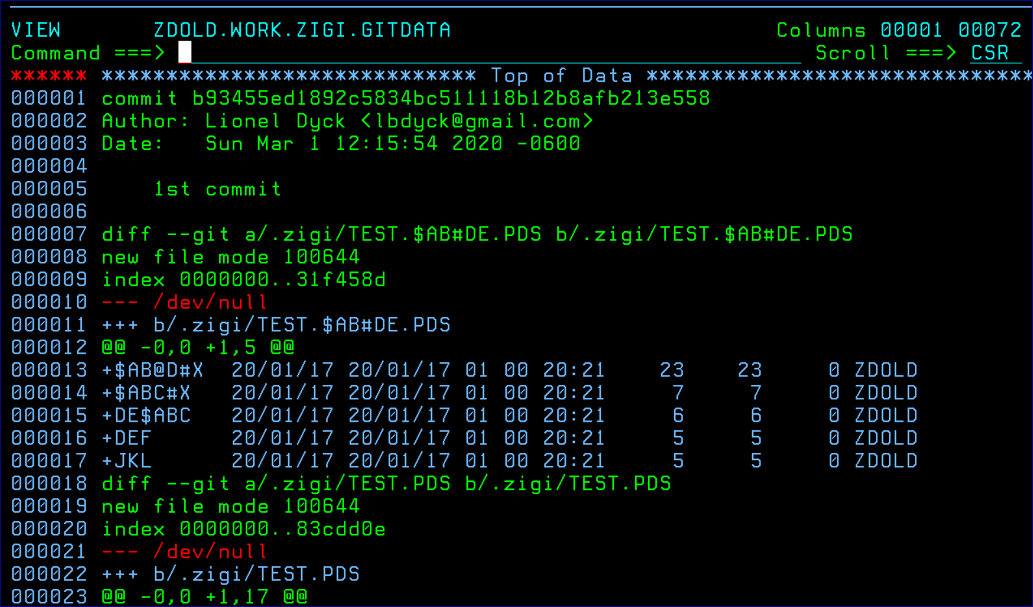

## Grep Command

The **Grep Command Entry** screen prompts for a string and then searches the local repository for that string.

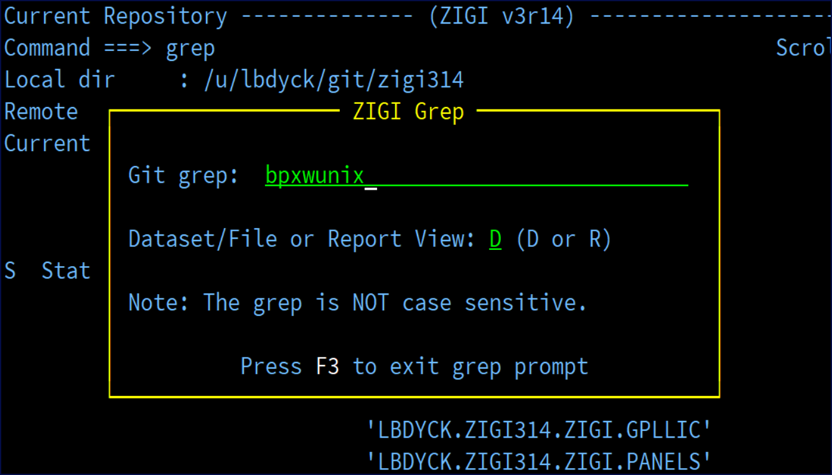

The results display on the **Grep Datasets/Files** view:

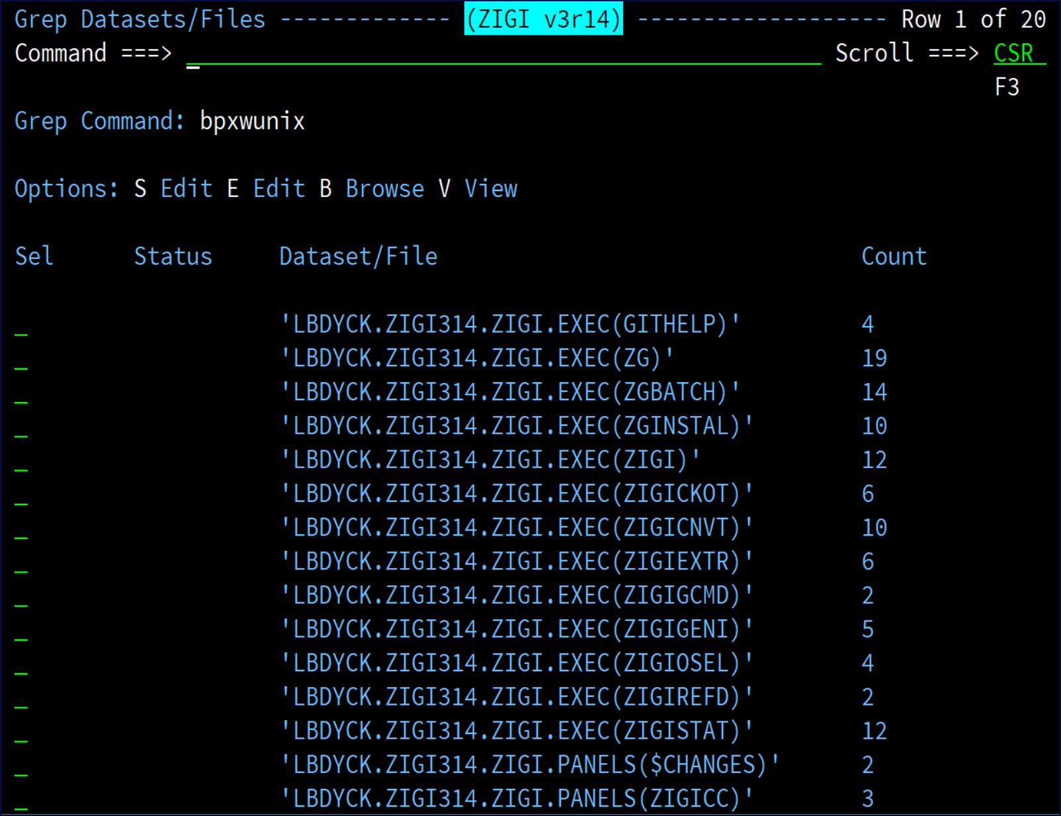

This view presents each of the data sets, or data set(member), where a hit was detected along with reporting how many hits were found in each. You have the ability to Browse, Edit, or View each.

The following image shows the results for the Report view:

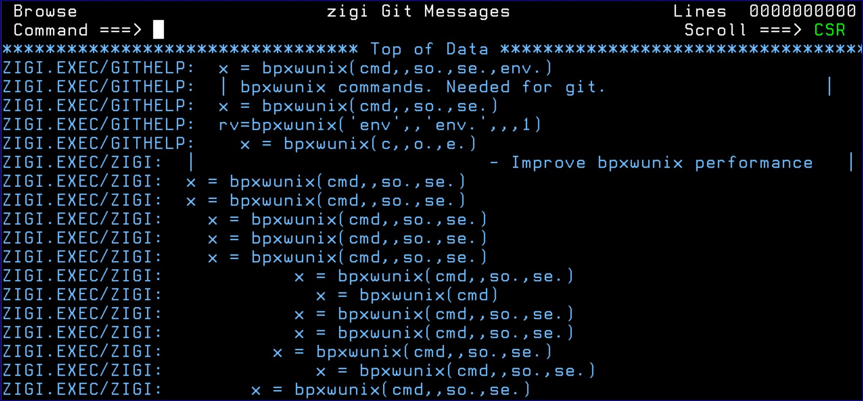

## Info Command

The **zigi Local Repository Summary Info** screen displays a short summary of information about the repository.

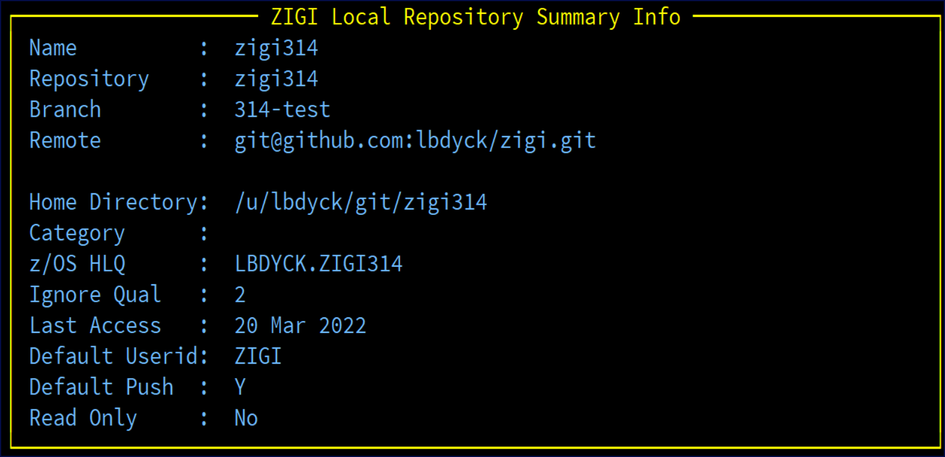

## Network

Network displays the git log graph report, which can be helpful to see the branch structure of the commit history.

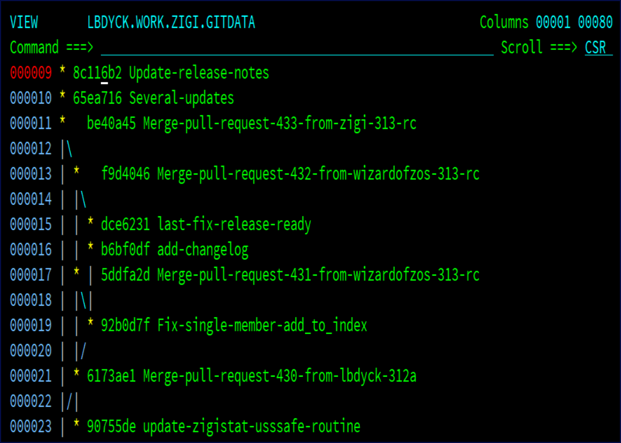

## Options Menu Assist

Use O on the command line to bring up a pop-up menu of all available commands. This is useful if you have selected to use the Pro or Hidden menu.

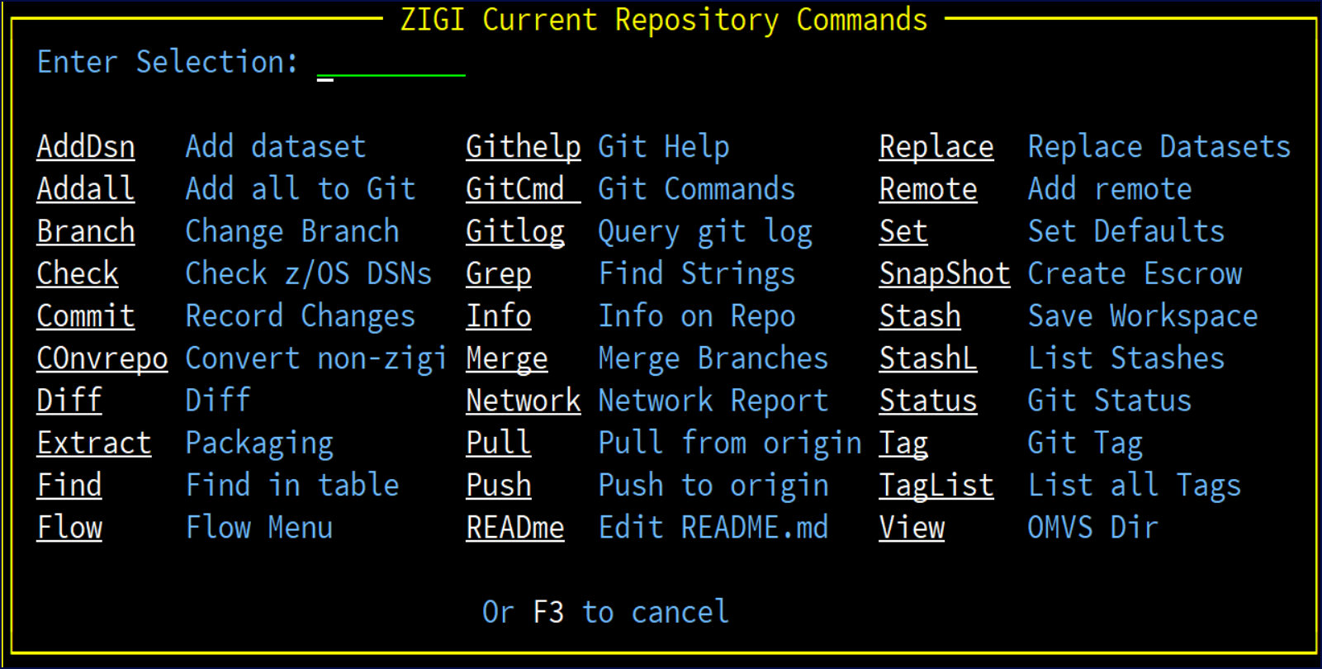

## Pull

Pull copies from the remote repository and replaces the updated files in the local OMVS filesystem. After the pull, the updated z/OS data sets are automatically refreshed.

## Push

Push pushes the current branch to the remote repository.

## Readme

Readme will create a README.md or edit and existing README.md file in the local repository

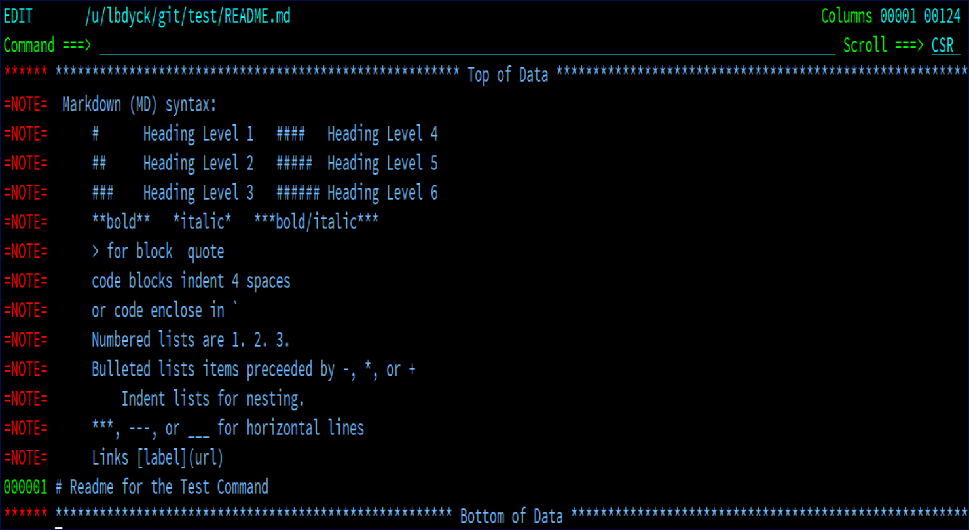

## Replace

Replace replaces all of the current z/OS data sets in the repository with the data in the local repository's OMVS filesystem, including maintaining the ISPF statistics when those data sets were added to the OMVS filesystem. All refreshed partitioned data sets are allocated as PDSE version 2 libraries with the default MAXGEN. If the refreshed library is a PDS, and more than 25% of the members are being updated, then the PDS is reallocated as a PDSE Version 2 with the default MAXGEN. If the refreshed library is a PDSE then it is not reallocated and only the updated members are refreshed.

## Remote Command

The Remote command is used for newly created local repositories to be associated with a remote repository.

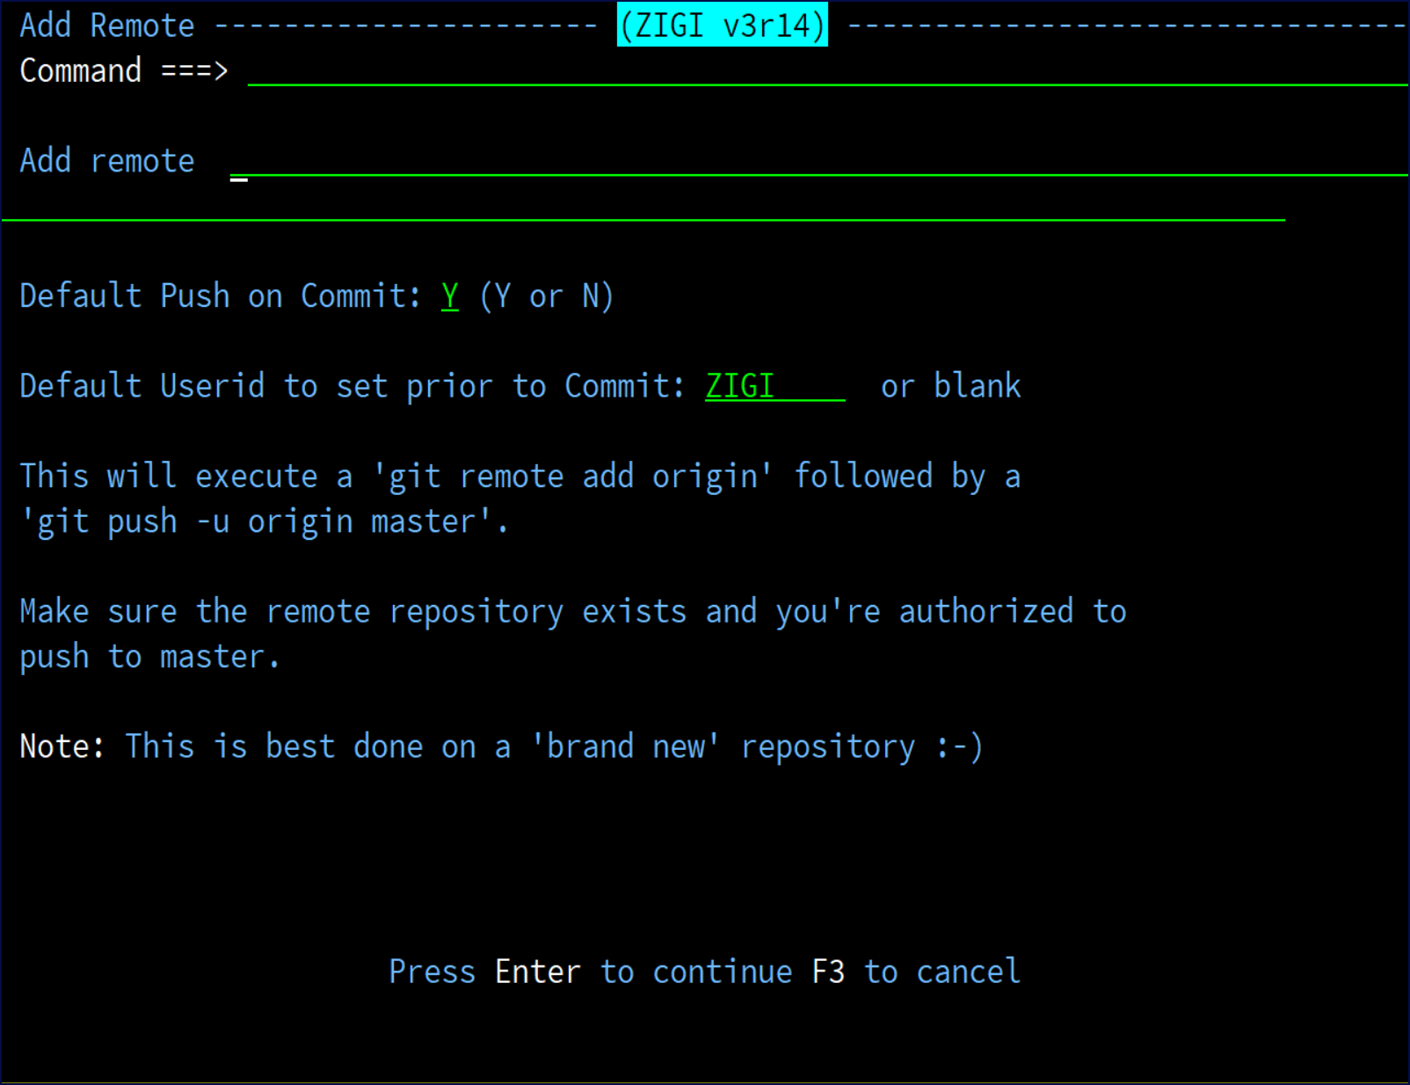

## Set Command

The Set command is used to define default actions for you.

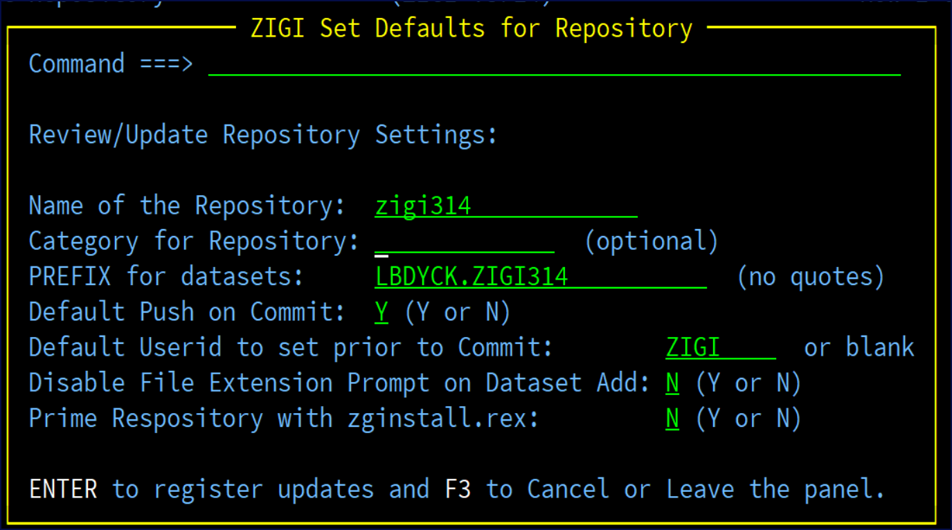

**Name of the Repository** is the name of the OMVS directory where the repository resides and if changed only results in the name of the repository in the Local Repositories table. The directory is not changed.

**Category for Repository** is an arbitrary description for the repository that allows you to categorize, or group, repositories.

**PREFIX for datasets** is used to define the z/OS data set HLQ that was used when the repository was created or cloned. The Prefix may be changed, and all z/OS data sets are renamed, and depending upon the qualifiers to ignore (see the INFO display) it is possible the OMVS files and directories may be

renamed as well. To change the Prefix requires that the new prefix have the same number of qualifiers as the original prefix. If OMVS files and/or directories are changed, then git is also updated to be aware of the rename.

**Default Push on Commit** has an option to push after the commit. This setting provides a default, which you may override on the Commit panel at anytime.

The **Default Userid to set prior to Commit** is what all PDS members ISPF Stats are set to when they are processed by Commit. Only those members have their ISPF Stats updated to the specified userid.

**Note:** Do not use 8-character userids unless your system has enabled their use.

The option to **Disable File Extension Prompt on Dataset Add** can be enabled or disabled here.

If the repository is to be distributed to others who may not have ZIGI installed, use the **Prime Repository with zginstall.rex** option to place a zginstall.readme and the zginstall.rex into the repository. See Appendix B: Using ZGINSTALL.REX for additional information.

## Snapshot

Snapshot creates an Escrow set of data sets and OMVS files from the current repository outside of Git. This can then be used for packaging and distribution, as well as an archive or backup for auditing and safekeeping purposes.

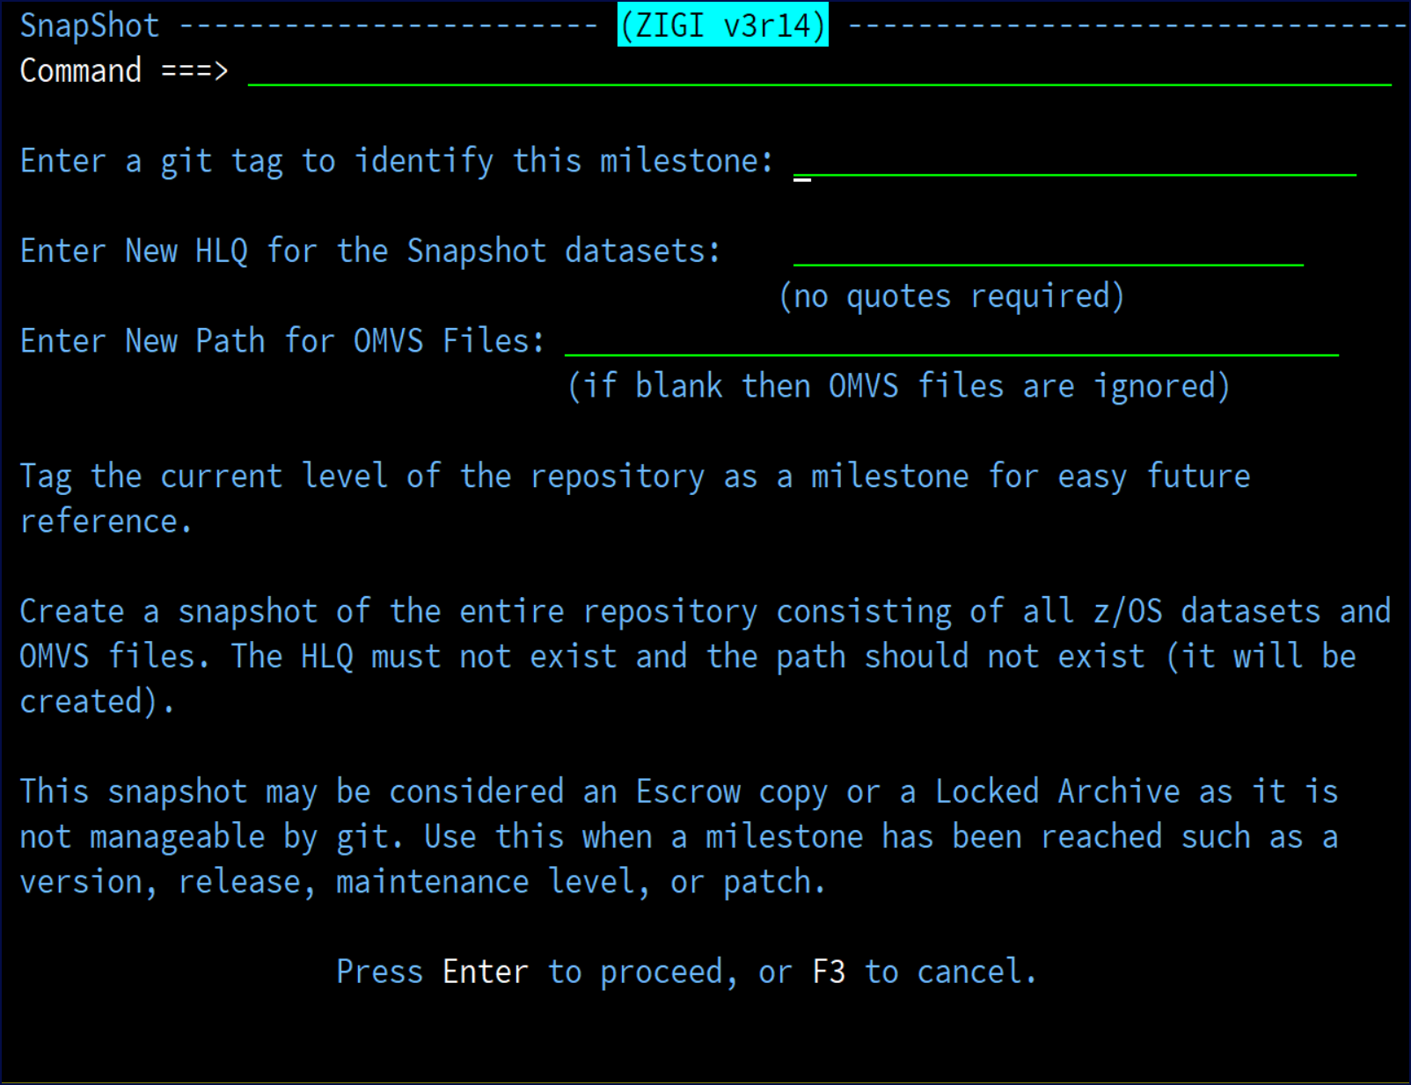

## Stash

Stash saves (pushes) your current Git workspace and restores the workspace to the last commit level. This allows you to quickly switch what you’re working on and work on something else without forcing a commit.

**Note:** A stash is never pushed to the remote server. Enter a short description on the **zigi Prompt Popup**

screen since you may have multiple stashes in your project.

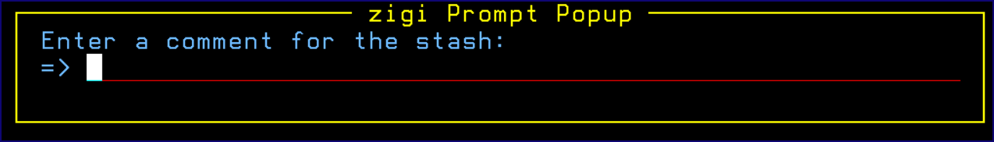

## Stash List (STASHL) Command

This topic explains the functionality of the Stash List (STASHL) command.

The Stash list (STASHL) command lists all stashes in the current repository and provides a number of options.

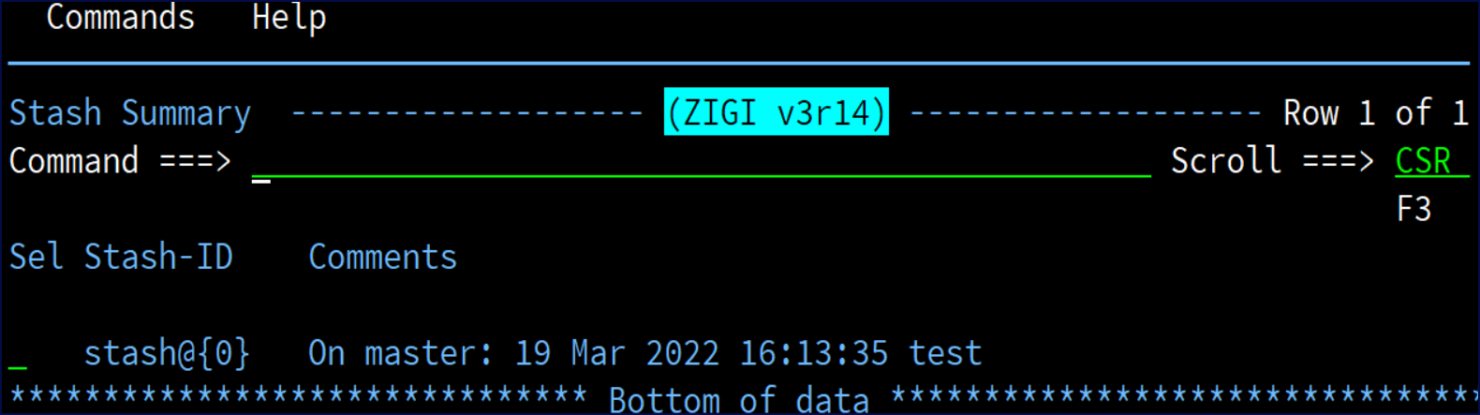

Available commands with Stash List are currently limited to one at this time. The Clear command removes all stashes in the current repository. Use this only if you are positive you don’t need them anymore. Enter a

/ in the row selection field to view available line selections:

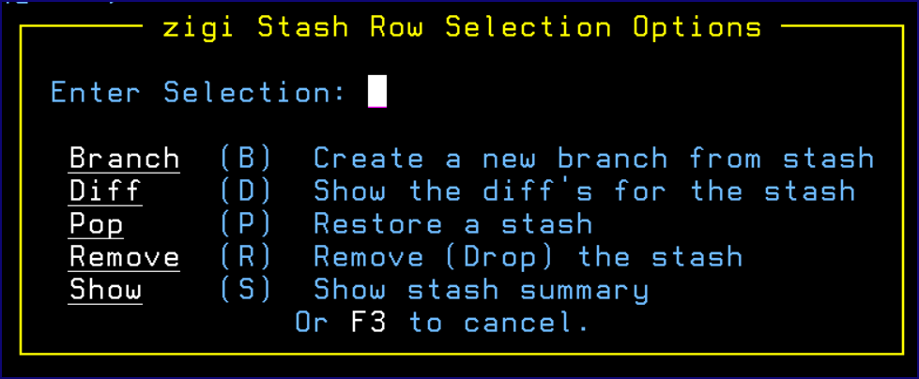

### Branch

Branch creates and checks out a new branch starting from the commit at which the *stash* was originally created and then applies the changes recorded in the stash to the new working tree and index. If that succeeds, it then drops the stash. This is useful if the branch on which you ran git stash save has changed enough that git stash apply fails due to conflicts. Since the stash entry is applied on top of the commit that was HEAD at the time git stash was run, it restores the originally stashed state with no conflicts.

### Diff

Diff uses the Stash Show command with option -p to display the stash summary along with the differences between the last commit and the stash.

### Pop

Pop removes a single stashed state from the stash list and applies it on top of the current working tree state (for example: do the inverse operation of Git stash save). The working directory must match the index. For simplicity sake, ZIGI validates that the current workspace is clean before performing a stash pop. This is because numerous conflicts could arise that would require manual intervention and the authors were unable to find a reliable methodology to resolve those conflicts programmatically.

#### Pop Conflict Resolution

There are two potential solutions that may be used to create a clean workspace:

* Create a new stash from the workspace, and then pop the desired stash.
* Perform the following actions:
  1. AddAll to add all untracked and modified data sets and files to the Git index staging area.
  2. Commit those changes.

After performing either of the above, the pop should work.

### Remove

Remove drops the selected stash from the current repository.

### Show

Show displays a summary of the differences between the stash level and the most recent commit.

## Status Command

The Status command displays the Git status command results:

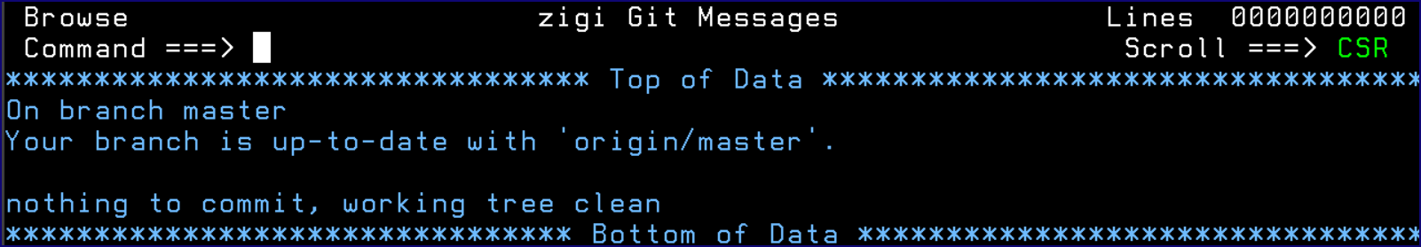

## Tag

Tag adds a Git Tag to the current repository and the tag is pushed to the remote server.

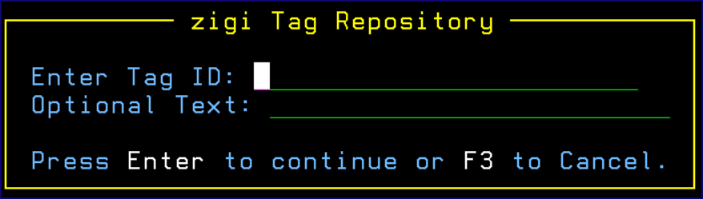

A lightweight tag, one without the optional text, is very much like a branch that doesn’t change — it’s just a pointer to a specific commit. Annotated tags, those with the optional text; however, are stored as full objects in the Git database. They are check summed; contain the tagger name, email, and date; have a tagging message; and can be signed and verified with GNU Privacy Guard (GPG). It’s generally recommended that you create annotated tags so you can have all this information; but if you want a

temporary tag or for some reason don’t want to keep the other information, lightweight tags are available too.

## TagList

TagList displays a selection table of all the Tags.

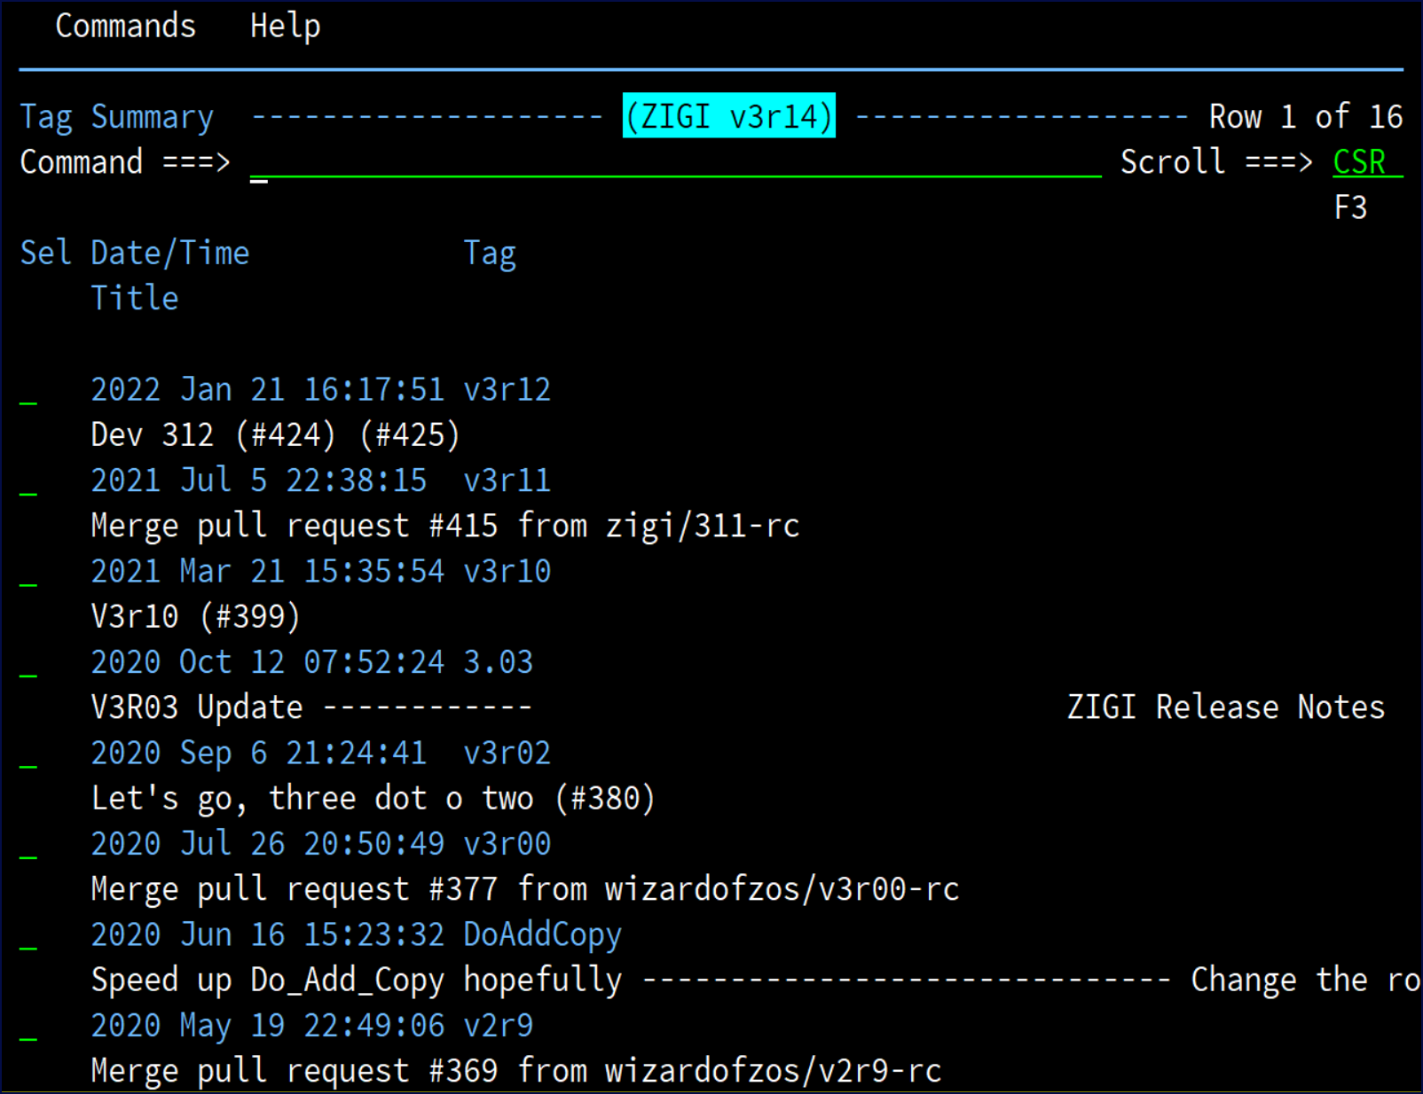

The table may be filtered using the Only command (for example: only x) and Refresh recreates the table with all entries. A row selection of S displays the tag details while a selection of C creates a new branch based on the tag level of the repository. This not only changes the OMVS filesystem files to match the tag level file, it also replaces all z/OS data sets to the tag level. Selection X extracts all the changed elements from all the selected tags into a non-Git managed set of z/OS data sets and OMVS directory. This can be used for packaging to distribute only the updated elements (for example: PTF). A row selection option of / brings up the **ZIGI TagList Line Options** pop-up:

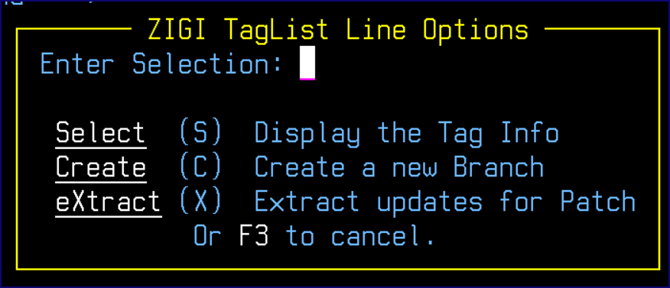

The **zigi Tag Recovery Prompt** pop-up asks for the name of a new branch for the tag level code:

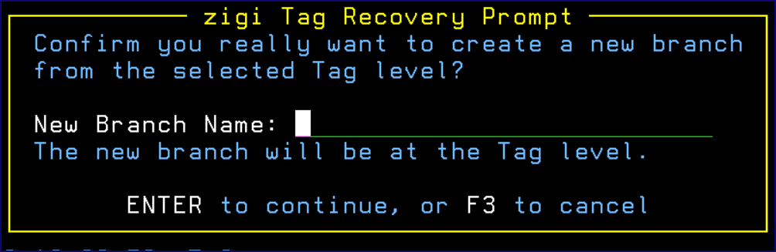

## View

The View command invokes the ISPF 3.17 (UDList) service on the active local repository filesystem.

## Row Selections

### Select Option

The Select option, or point-and-shoot, performs one of two different actions depending upon the type of data set being selected. After editing a sequential data set, if the data has changed, it is copied down to the OMVS file.

Open an Edit member list for a PDS. See The ZIGI PDS Member List for more information.

If the selected file is an OMVS directory, then ZIGI opens that directory and displays it using the Current Repository routines.

### Add Option

The Add option adds the data set (if sequential), or any modified members of a partitioned data set, to the Git index making them available to be committed.

### Browse and View

The Browse and View options use ISPF Browse or ISPF View on the requested data set or file. If the requested data set or file is an OMVS subdirectory, then the action is the same as Select.

### Diff

Diff displays the Git differences between the current data set, or file, and the Git commit version of the file. See Diff Option for more information.

### History

History views a history of commits for the data set, or file, with an option to view the source as of the historical point in time. See History Option for more information.

### Undo (U)

Undo (U) reverts any changes made to a data set or OMVS file before a commit. This means the status is [M}, {M], or [MM].

**Note:** Undo does not work on a full PDS, it only works on PDS members.

### Remove (RM)

Remove (RM) deletes the z/OS data set, the OMVS file, or the OMVS directory. It also deletes it from Git management. This can be undone before, or after, commit processing using Rollback.

### Rename (RN)

The Rename (RN) command renames the z/OS data set, the OMVS file, or the OMVS directory and then updates Git.

**Note:** Git does not retain any of the Git histories from the original name.

### / Row Selection Prompt

If a / is entered for a row selection, the **zigi Current Repository Selections** pop-up aids you:

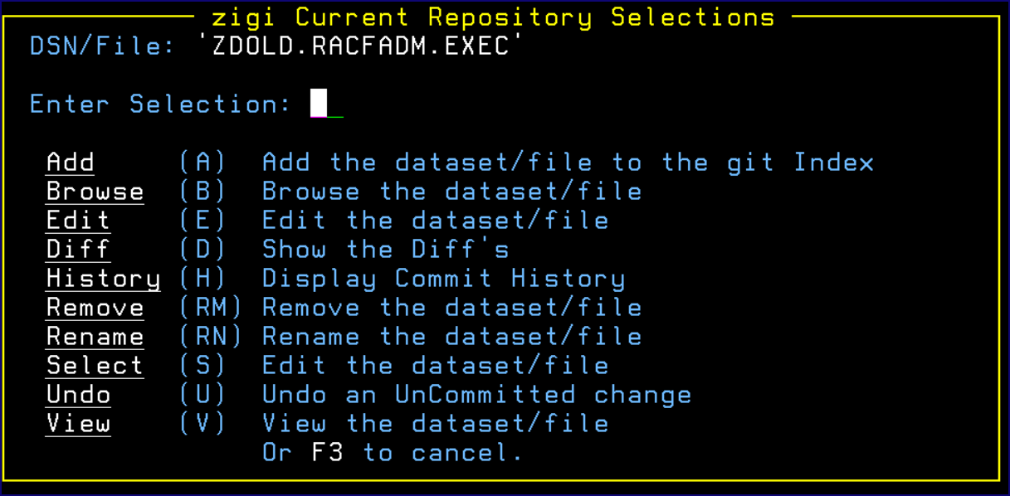

# The ZIGI PDS Member List

From the Repository display, if the selected data set is a PDS, then the **PDS Member List** displays:

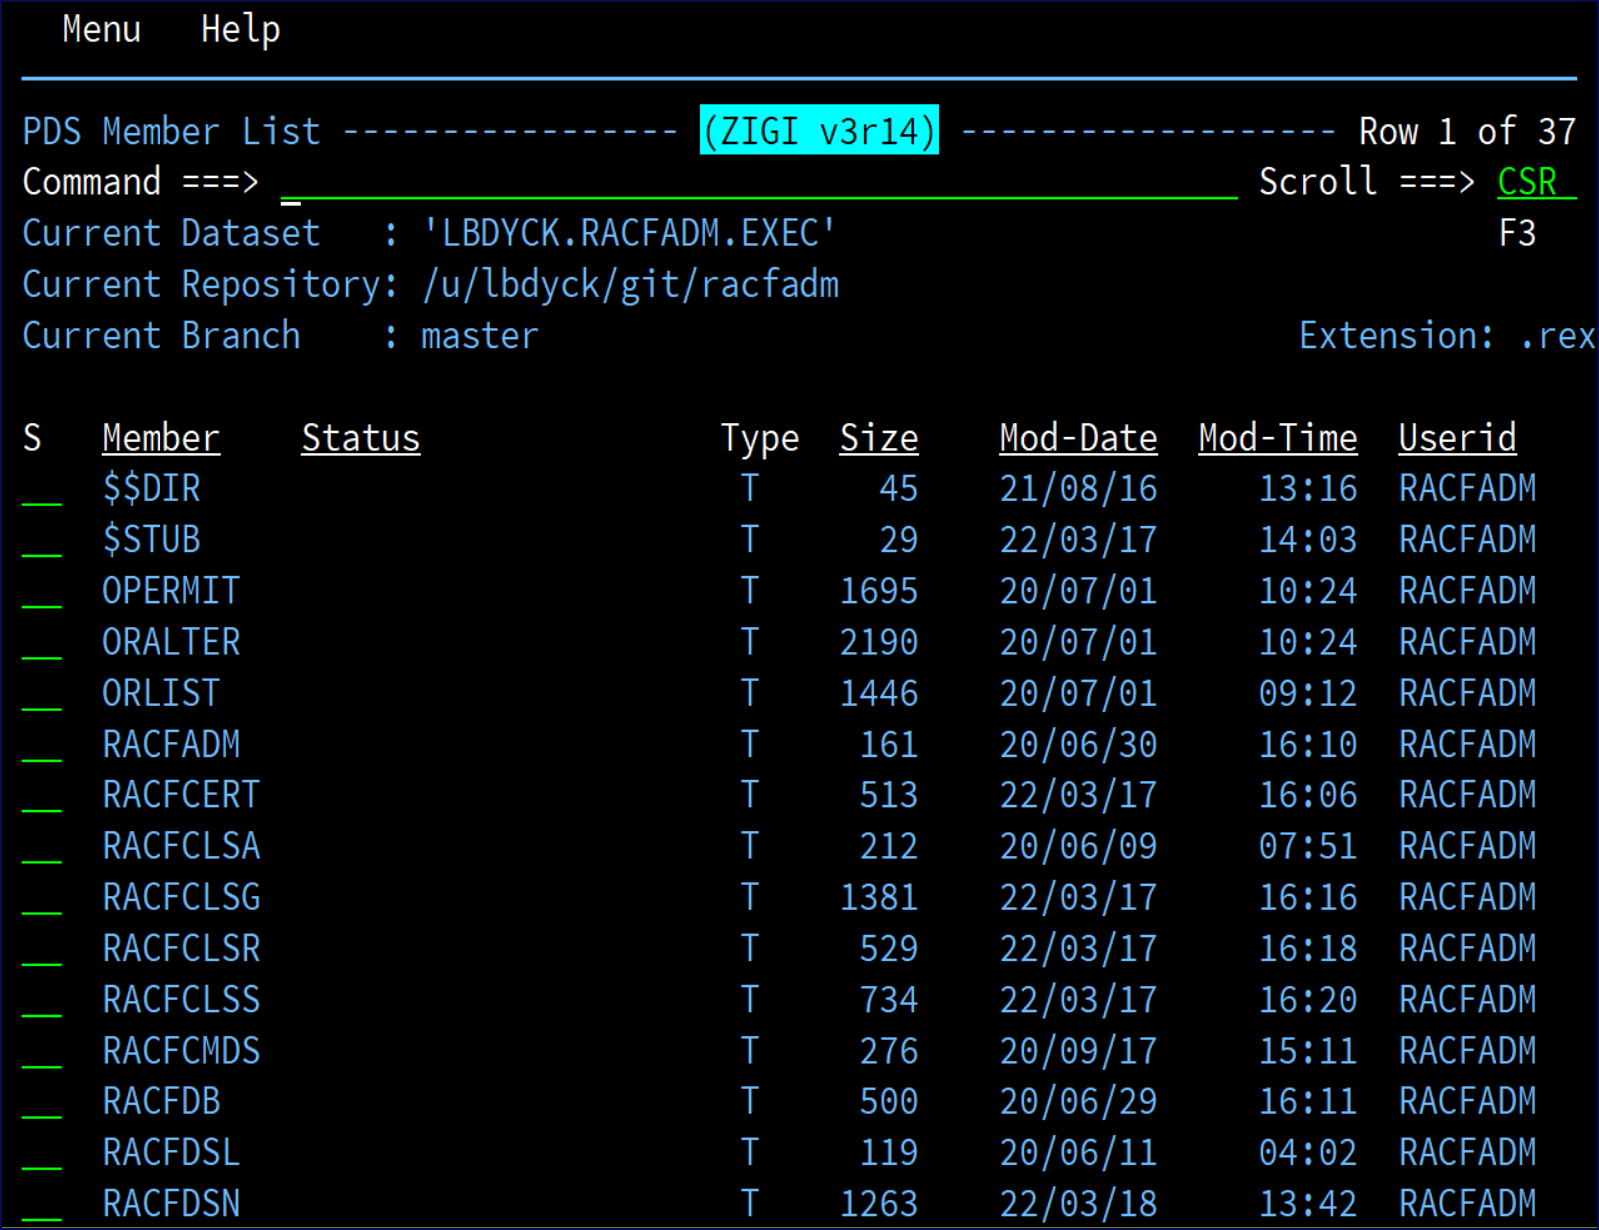

**Note:** The **Type** column contains a **T** if the member is a text member and a **B** if it is binary.

## Action Bar Menu

This topic provides a screenshot of the action bar menu.

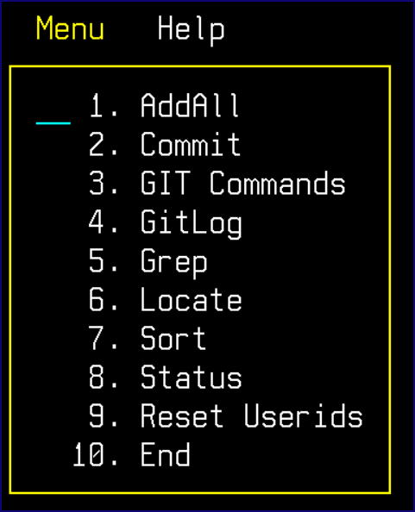

## Locate Command

The locate command finds a member that starts with or matches the string provided (for example: L GIT finds the member GITHELP).

## Commit

See Commit Command.

## GitLog

See GitLog Command.

## Grep

See Grep Command command.

## Sort Command

The Sort command sorts one column in either **A (ascending)** or **D (descending)** order. When entered without parameters, the **zigi Sort Selections** panel assists you:

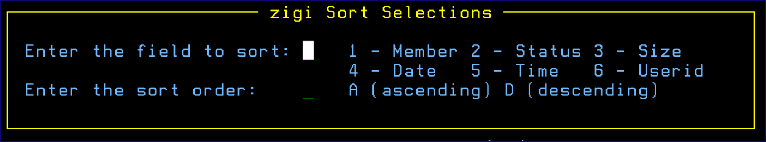

The sort syntax is: SORT field order

If the order parameter is blank, then it defaults to **A (ascending)**. The field names may be abbreviated:

|  |  |
| --- | --- |
| **Field** | **Abbreviation** |
| MEMBER | ME |
| STATUS | ST |
| SIZE | SI |
| DATE | DA |
| TIME | TI |
| USERID | US |

## Status

See Status Command for more information.

## Reset-IDs Command

The Reset-IDs command prompts to change the userids of all members to a new userid. This is useful to hide your userid or to make all userids conform to a standard for promoted elements.

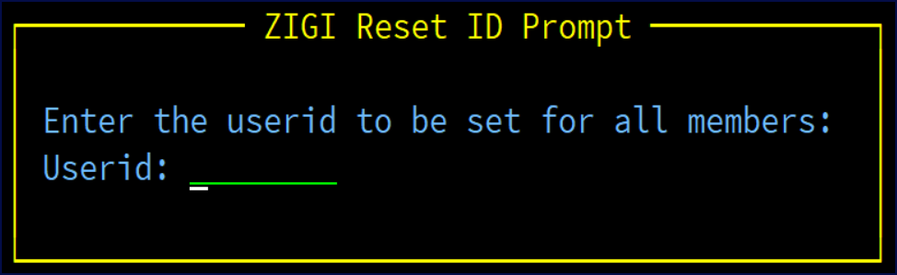

## Options (O) Command

The Options (O) command displays the **ZIGI PDS Member Commands** menu to assist you if you are using the terse or hidden menu option.

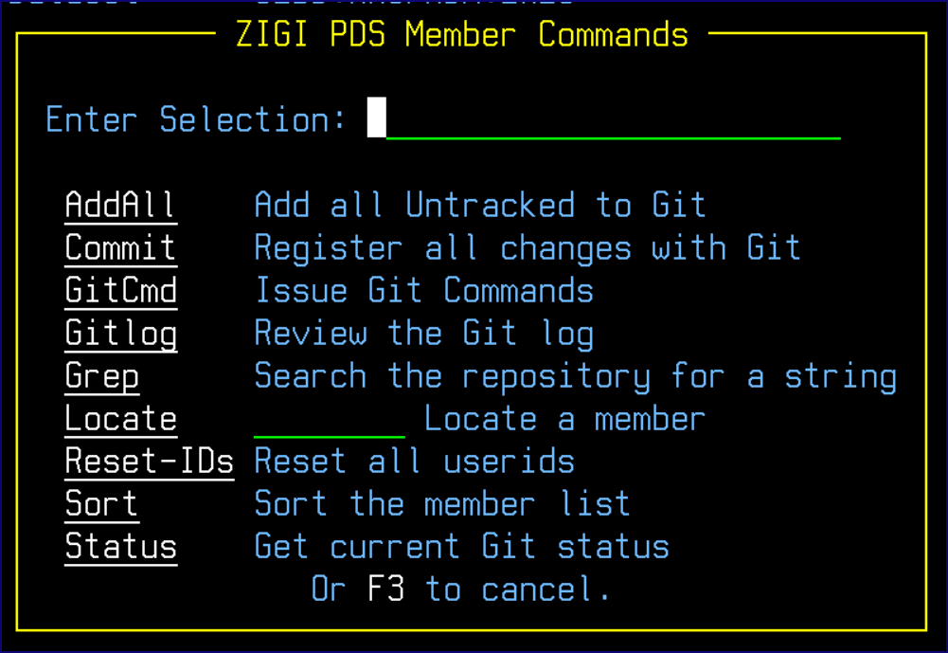

## Member Select Option

S, or point-and-shoot, selects the member to be opened using ISPF Edit. If the member is changed during the Edit session, then it is copied from the z/OS data set to the OMVS filesystem.

### Add Option

The Add option adds the member, as text, to the Git index making it eligible to be committed.

### AddBin Option

The AddBin option adds the selected member to Git in binary format and tags the OMVS file copy of the member as binary. The .gitattributes file is updated with the OMVS directory and file name so that Git always treats it as binary. This is useful for object decks and other data that should never be converted from EBCDIC to ASCII and back.

Using this option may be required for some PDS members that contain data in binary, such as some ISPF panels.

### AddForce (AF) Option

The AddForce (AF) option forcefully adds a member if the member had been previously ignored.

### Browse Options

Browse opens the member using ISPF Browse.

### Diff Option

Diff option compares the active file in the OMVS filesystem with the last index for the file.

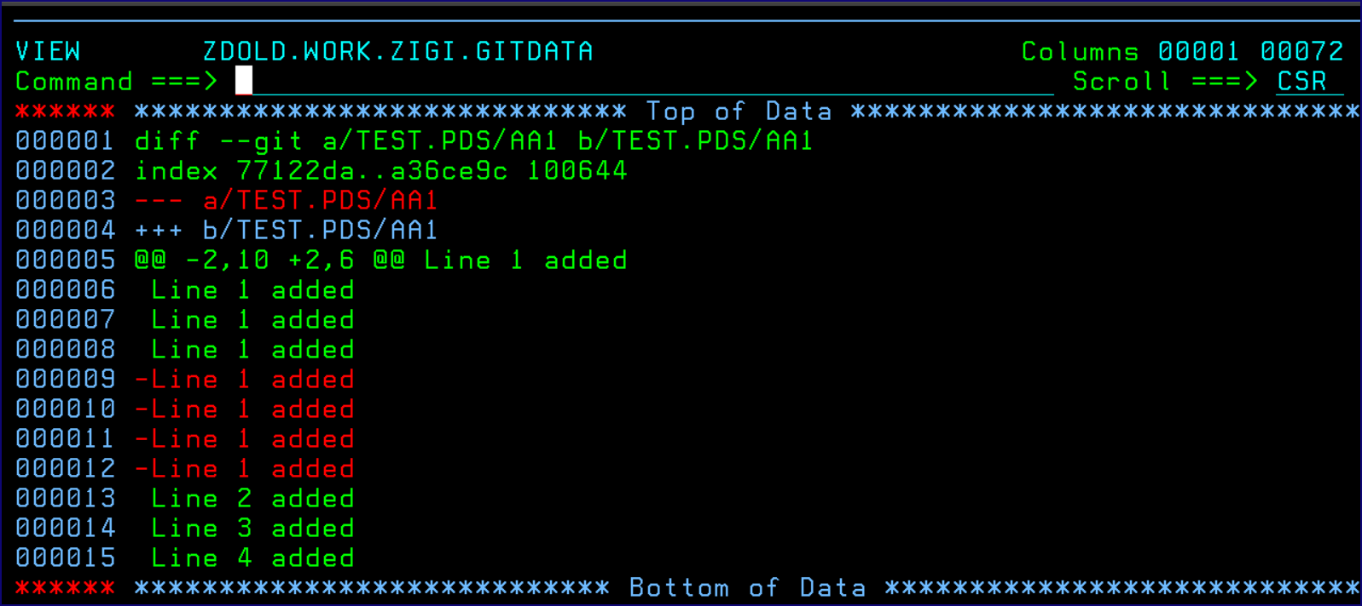

The diff is displayed using ISPF View that has been enhanced to highlight the additions and deletions in the file. If there have been no changes since the last commit, then there is nothing to compare.

### History Option

History shows a selectable list of all commits for the selected member. From this list, the full source from that point in time may be viewed or the commit with diffs can be viewed:

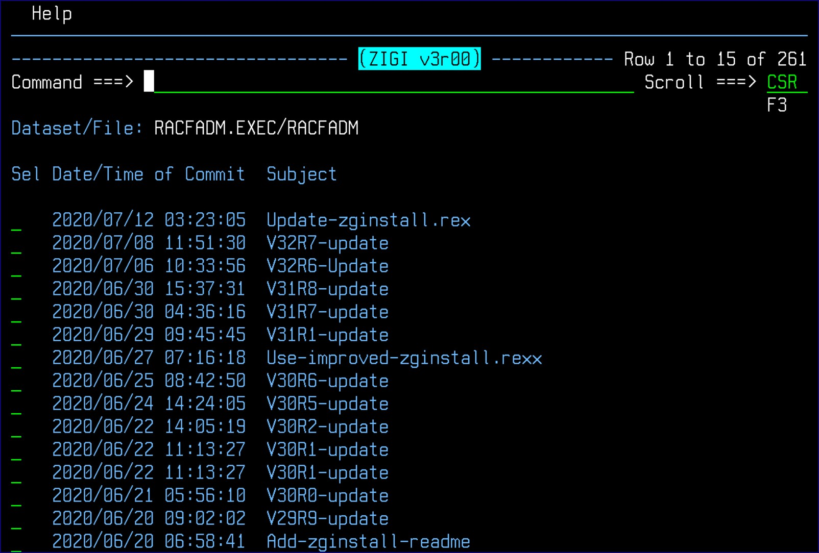

The row selection of / displays the **zigi History Selection Options** to guide the selection of the row command:

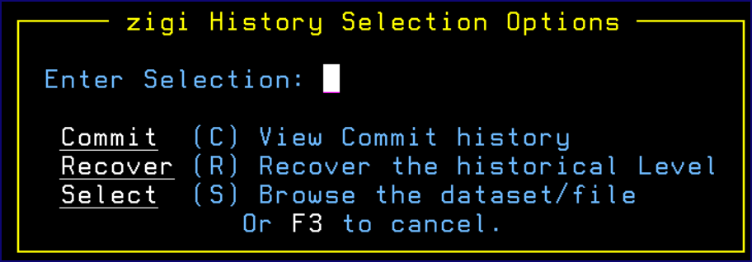

#### Commit View

The Commit view can be used to see the changes made with a specific commit.

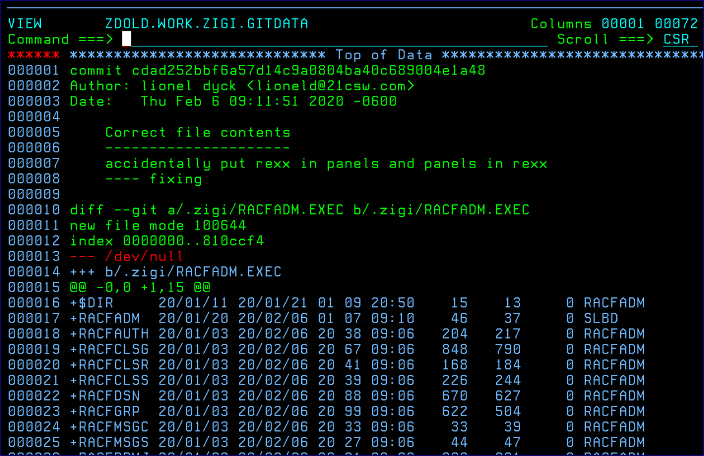

#### Source View

This view of the source is from a specific commit. It is placed into a z/OS data set to allow you to use the ISPF Edit Compare, Create, and Copy commands, among other commands.

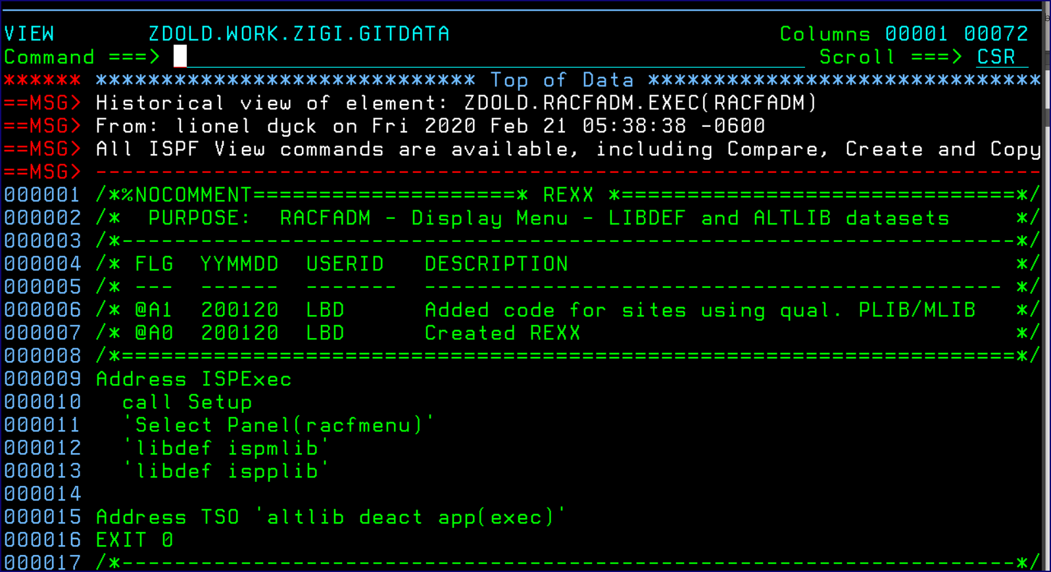

#### Recovery

Recovery prompts for a recovery data set if that data set should be allocated new and a confirmation of the recovery. Recovery can occur in the active data set if desired but with an additional confirmation prompt.

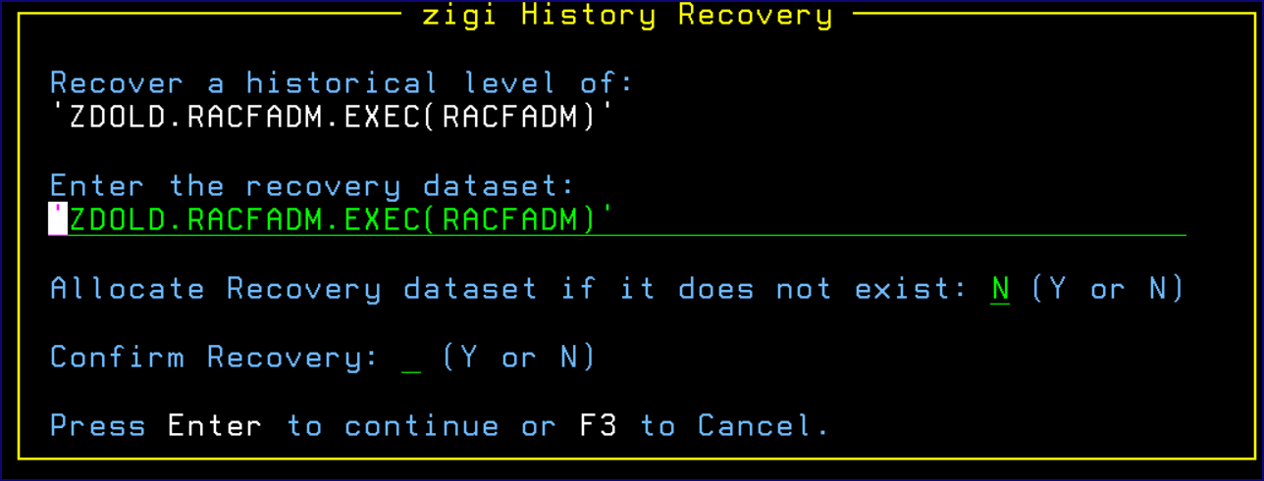

### Ignore

The Ignore (I) option causes a member to be ignored by Git. The member is not included in the repository when it is pushed, cloned, or merged.

### Remove and Rename

See [Remove (RM)](#_Remove_(RM)) and [Rename (RN)](#_Rename_(RN)) which applies, in this case, just to the PDS Member.

### Undo

Undo reverts any changes made to a PDS member before a commit. This means the status is [M}, {M], or [MM].

### View

View the data set or file using ISPF View.

### / Row Selection Prompt

If a / is entered for a row selection, the **ZIGI PDS Member Selection Options** menu aids you:

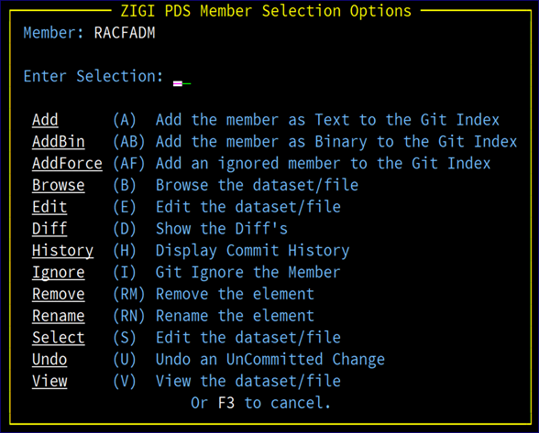

# Typical ZIGI Activities

ZIGI is intended to be used as the interface to Git. All development activity should be performed outside of ZIGI using your favorite ISPF-based tools. Once a development phase is complete, ZIGI can be activated to commit and push the update.

## Creating a New Repository (Local and Remote)

There are two ways of creating a (Git-based) repository with ZIGI:

* Cloning a remote repository or creating one from scratch locally.
* Using the create command to create a new (local) repository.

This performs a git init *repoName* in the chosen directory. A basic .gitattributes is created and added/ committed to your repository. This is there to ensure that the encoding of the various Git-managed files are in the correct format. After creating the local repo (ZIGI takes care of your .gitattributes file) you can ADD data sets to the repository. (See ADDall Command command).

Adding files to ZIGI is not the same thing as adding them to the Git repository. Once a data set has been added to ZIGI, the data sets (in file-format) are only available in the working-space of the Git repository. (They are present in /*repofolder*/*reponame*).

Adding to the Git-repo is done via the add (A) line command.

## Adding a Remote Repository

ZIGI currently only supports a single remote (origin) per repository. Once you have a local repository, you can use the remote command to add this single remote to your local repository.

To do so, the remote repository (GitHub, BitBucket, GitLab, etc.) needs to associate the public part of your Mainframe ssh key pair with the userID for the remote repository service. Once you’ve set up the repository on the remote side, you can add the remote within ZIGI. A push – u origin master is performed.

## Updating a Local Repository

**About this task**

**Attention:** This topic is intentionally left blank. The authors are looking for input from those who use the ZIGI product to write the information for this topic.

**Procedure**

## Pulling Updates from the Remote Repository to Update the Local Repository

**About this task**

**Attention:** This topic is intentionally left blank. The authors are looking for input from those who use the ZIGI product to write the information for this topic.

**Procedure**

## Pushing Updates to the Remote Repository

**About this task**

**Attention:** This topic is intentionally left blank. The authors are looking for input from those who use the ZIGI product to write the information for this topic.

**Procedure**

## Changing to a Different Existing, Or New, Branch

Changing to a different branch requires the current branch be clean. Clean means that all changes have been committed. Once the branch is clean, use the Branch command and either select an existing branch using C (for checkout) or enter the name of a new branch.

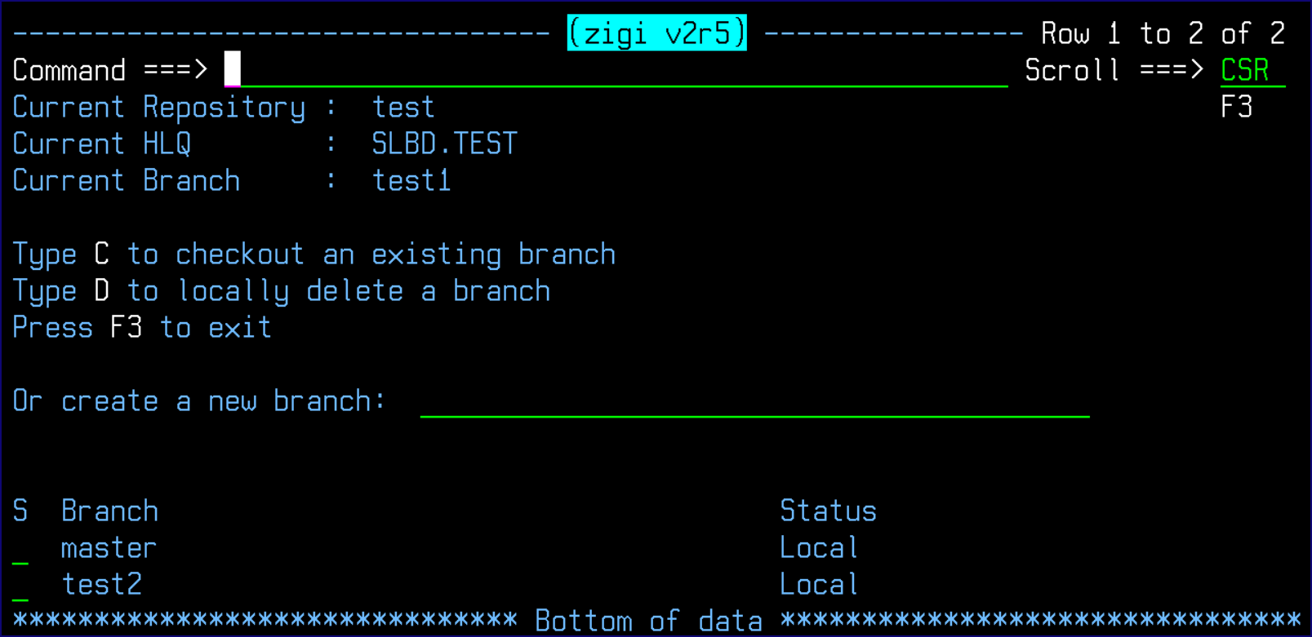

When changing to an existing branch:

1. Git updates the Git index and all the files in the workspace to the state in the selected branch.
2. ZIGI then replaces all the existing z/OS data sets with the OMVS files that correspond to the branch. When changing to a new branch:
3. Git creates a new Git index for the new branch with the state of the current files.
4. ZIGI updates its status to use the new branch.

# What is Happening Under the Covers?

When ZIGI opens a repository, the first action is to check the remote server for updates. If there are updates, you are informed that the current branch is behind and needs updating (pull). ZIGI also checks all the z/OS data sets and the OMVS filesystem for updates, marking the z/OS data sets if there are modifications in play that need to be added to the index, committed, and pushed. If the data set is a sequential data set, it is always copied to an OMVS file so that Git can detect changes. For a PDS, if the member is new then it is copied to the OMVS directory that maps to the PDS. If a file extension has been

defined for the PDS, then the member is copied using the file extension. The extension is defined when the data set is added to ZIGI and stored in the .zigi/dsn file.

This picture provides an example of a ZIGI OMVS filesystem layout.

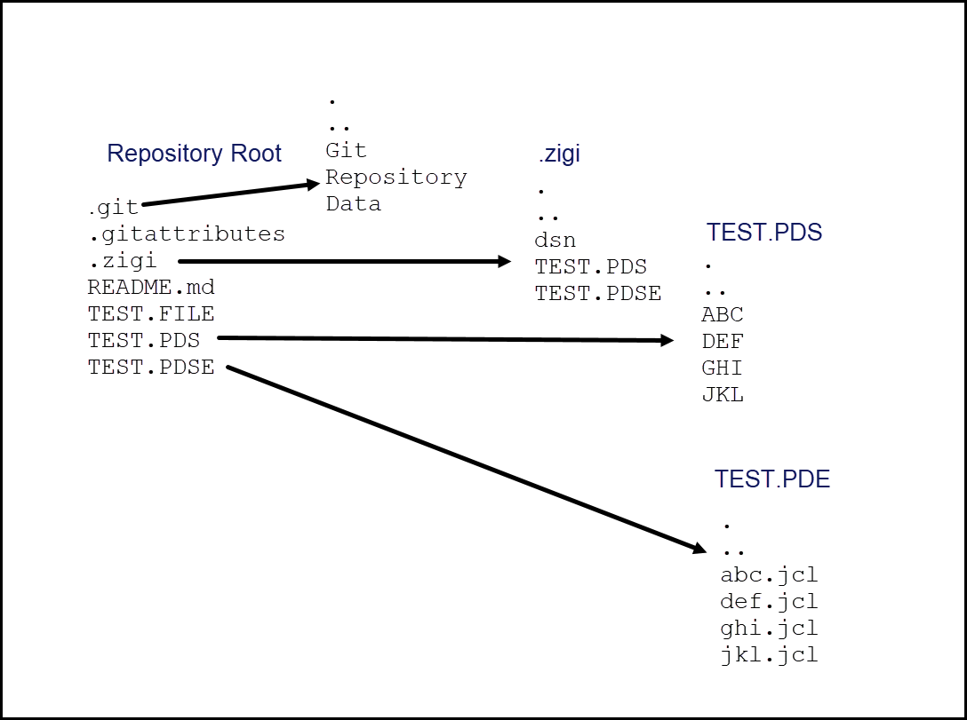

When a PDS is updated, the ISPF statistics for all members are captured and an OMVS file is updated to accurately reflect the current statistics. This file is then used to compare the members to identify if there are any new or changed members and then flags them. The file is also used during a replace, clone, or pull operation to reset the ISPF statistics as Git has zero awareness of them.

As data sets are added to ZIGI, an OMVS file is updated with the DCB information for that data set. This file is then used during a replace, clone, or pull operation to correctly allocate the z/OS data sets. The space for those data sets is dynamically determined based on the OMVS filesystem usage and are allocated as PDSE version 2 libraries with a zero MAXGEN.

# ZG - ISPF Command

There are times when an element is being edited (updated) within a PDS that is part of a ZIGI managed repository. After completing the update, just that element needs to be processed by Git. To edit an element, use the ZG command.

The syntax is: ZG *data set(member)* option

Where: *data set(member)* is the element to be quickly processed by Git. Options:

|  |  |
| --- | --- |
| **Blank** | **Prompt for Option** |
| A | Git Add |
| AC | Git Add and Commit |
| ACP | Git Add, Commit, and Push |

For ease of use, zg may be entered on the ISPF member list row command next to the member name to be processed.

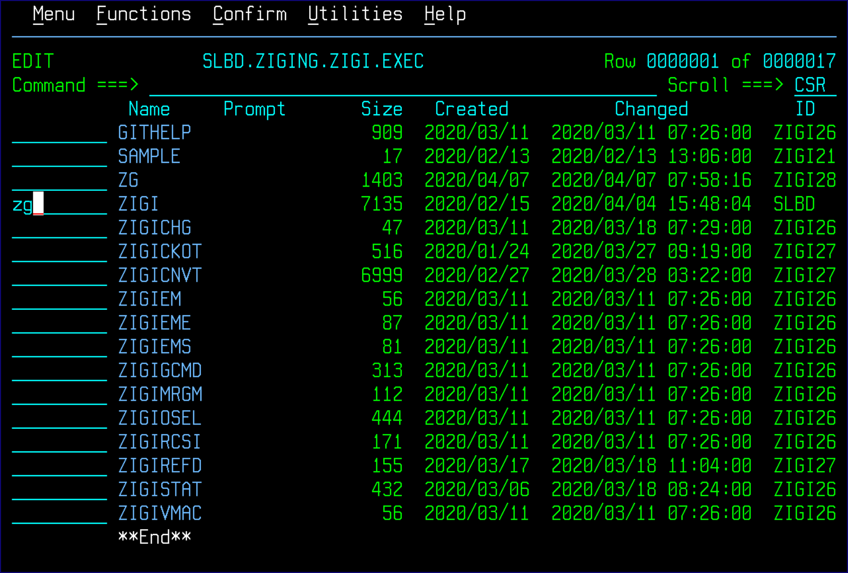

If the zg command has not been used before for this data set, then a list of all ZIGI-managed repositories are presented to select from:

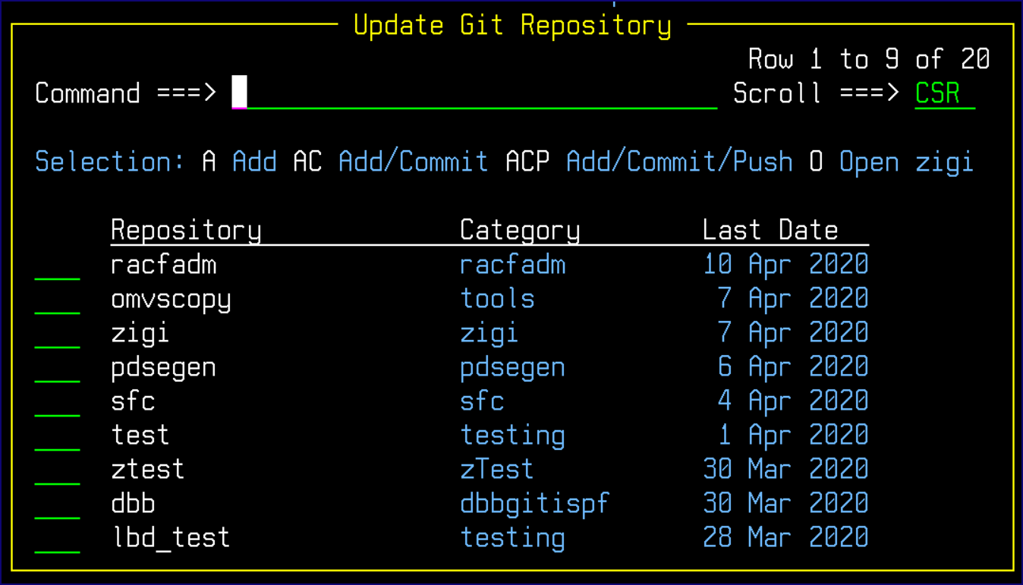

If zg has been used with that data set before, then the repository prompt is bypassed, and the **zigi Git Option** pop-up displays:

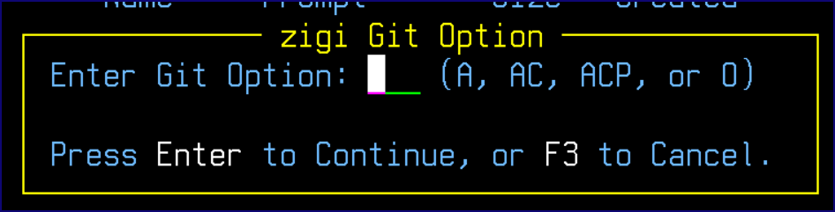

There is an additional option available via the pop-ups, O, which opens the repository.

# ZGBATCH - Execute ZIGI in Batch

There may be projects where there is a need to schedule ZIGI to check for updated and new elements in a repository's z/OS data sets, which is where ZGBATCH is used. Note that ZGBATCH does not support the Co:Z commands.

The following is sample JCL:

//ZGBATCH JOB XXX,’ZIGI’,REGION=0M,NOTIFY=&SYSUID

//OUT OUTPUT DEFAULT=YES,JESDS=ALL,OUTDISP=(HOLD,HOLD)

//* *

//* INVOKE ISPF IN BATCH *

//* *

//ISPF EXEC PGM=IKJEFT1B,DYNAMNBR=50

//* *

//* SYSEXEC IS WHERE THE CMD RESIDES *

//* *

//SYSEXEC DD DISP=SHR,DSN=zigi.exec

//* *

//* MLIB AND TLIB FOR THE REAL ISPF *

//* *

//ISPMLIB DD DISP=SHR,DSN=ISP.SISPMENU

//ISPTLIB DD DISP=SHR,DSN=ISP.SISPTENU

//* *

//* TEMPORARY PANELS, SKELETONS, AND TABLES ISPF LIBRARIES *

//* ALLOCATED TO VIO *

//* *

//ISPPLIB DD DISP=(,DELETE),SPACE=(TRK,(1,1,1)),UNIT=VIO,

// DCB=(RECFM=FB,LRECL=80,BLKSIZE=6160)

//ISPSLIB DD DISP=(,DELETE),SPACE=(TRK,(1,1,1)),UNIT=VIO,

// DCB=(RECFM=FB,LRECL=80,BLKSIZE=6160)

//ISPPROF DD DISP=(,DELETE),SPACE=(TRK,(1,1,1)),UNIT=VIO,

// DCB=(RECFM=FB,LRECL=80,BLKSIZE=6160)

//SYSTSPRT DD SYSOUT=*

//* *

//* SYSTSIN - THE BATCH TSO COMMANDS TO INVOKE ISPF *

//* *

//SYSTSIN DD * PROFILE PREFIX(userid)

ispf cmd(%zgbatch repo-prefix qualignr repo-directory P

/*

//COMMIT DD * (Optional) Commit subject line

Text line 1

Text line 2

/*

The zgbatch syntax is:

|  |  |
| --- | --- |
| **Parameter** | **Description** |
| Repo-prefix | This is the ZIGI-defined z/OS prefix for the z/OS data sets within the repository. |
| Qualignr | The # of qualifiers to ignore when constructing the OMVS filenames. |
| Repo-directory | The OMVS directory where the repository is located. |
| C or P | C to commit only or P to commit and push. |

# Timing (For Those Interested)

For those who may be interested in some of the internal timings, it is as easy as allocating a DD with the name of ZIGIDEBG. When ZIGI runs, time stamps for various routines and functions are recorded in a file in your home directory. When ZIGI ends, if the DD was allocated, the file is listed on the **z/OS UNIX Directory List** screen:

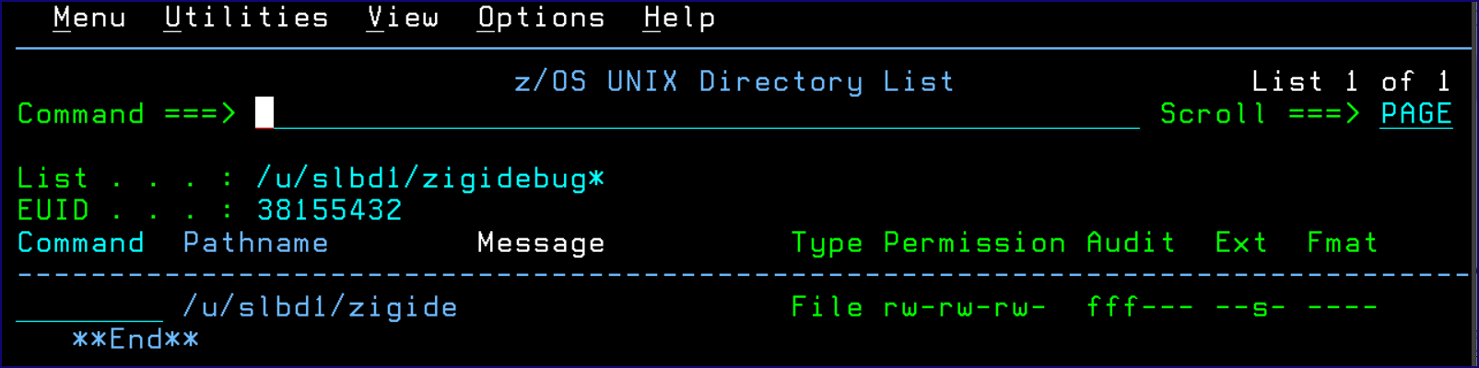

The file may be browsed, viewed, edited, or deleted.

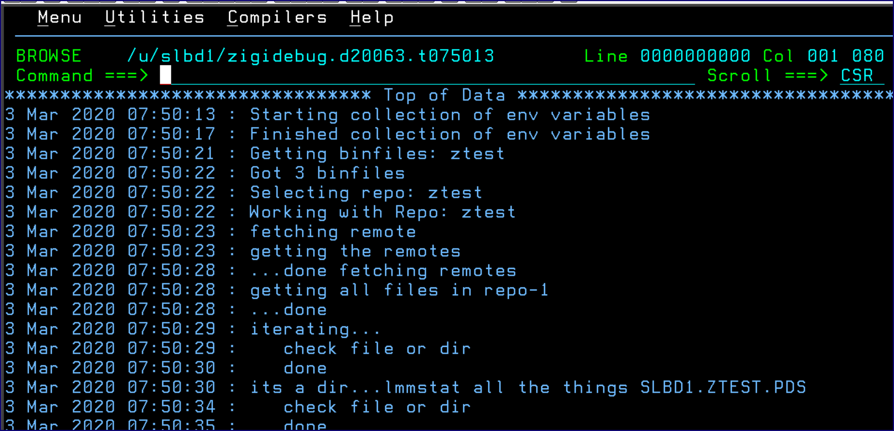

The active debug log may be viewed from several of the panels (Local Repository, Current Repository, and PDS Member List) by using the VIEWD command.

For those interested, here is a short EXEC that allocates and/or frees the ZIGIDEBG DD:

/* REXX *

| A toggle exec that will allocate the ZIGIDEBG DD |

| if it does not exist and if it does then it will |

| be freed. |

* */ x = listdsi('ZIGIDEBG' 'FILE')

if x > 0 then if sysreason = 3 then 'Free F(ZIGIDEBG)' else 'Alloc f(zigidebg) dummy reuse'

# Appendix A: Installing Git

Appendix A lists the actions needed to install Git.

|  |  |
| --- | --- |
| **Check** | **Action** |
|  | Create an OMVS user account with SuperUser (su) capabilities (for installing Git systemwide). |
|  | Allocate a good size ZFS (one that we are using is 500-600 cylinders). |
|  | Get access to PARMLIB member BPXPRM*xx* or someone who can update it for you to add the appropriate MOUNT statement for the new ZFS. |
|  | NEED to update for Conda – anyone care to contribute to this? |
|  | Exit OMVS and get back into OMVS, and then enter the command git version – if it works you have Git. |

|  |  |
| --- | --- |
| **Check** | **Action** |
|  | Now, unmount Git and tools zfs from the temporary mount point. |
|  | Create a new, permanent mount point and mount it. |
|  | Update PARMLIB BPXPRMxx with the MOUNT statement so that it is mounted at each IPL:  MOUNT FILESYSTEM(‘OMVS.GIT.ZFS’) TYPE(ZFS)  MODE(READ)  MOUNTPOINT('/usr/ported') |

# Appendix B: Using ZGINSTALL.REX

The zginstall.rex is a generic installation tool that works with any ZIGI-managed repository to recreate the z/OS data sets when a repository is cloned outside of ZIGI. It is intended for use when a site does not have ZIGI installed on z/OS to allow ZIGI-managed repositories to be installed easily.

To add zginstall.rex to a repository, use the SET command in the Current Repository and update the settings:

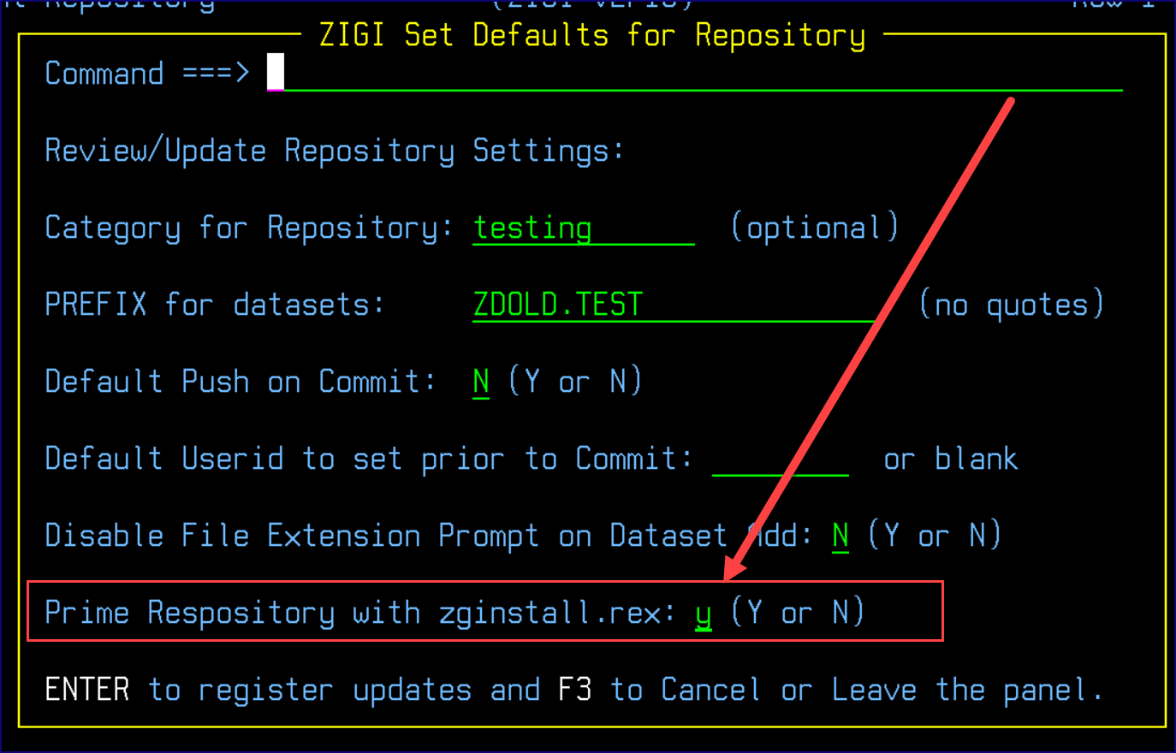

This generates a short and long message on the **ZIGI Git Messages** screen:

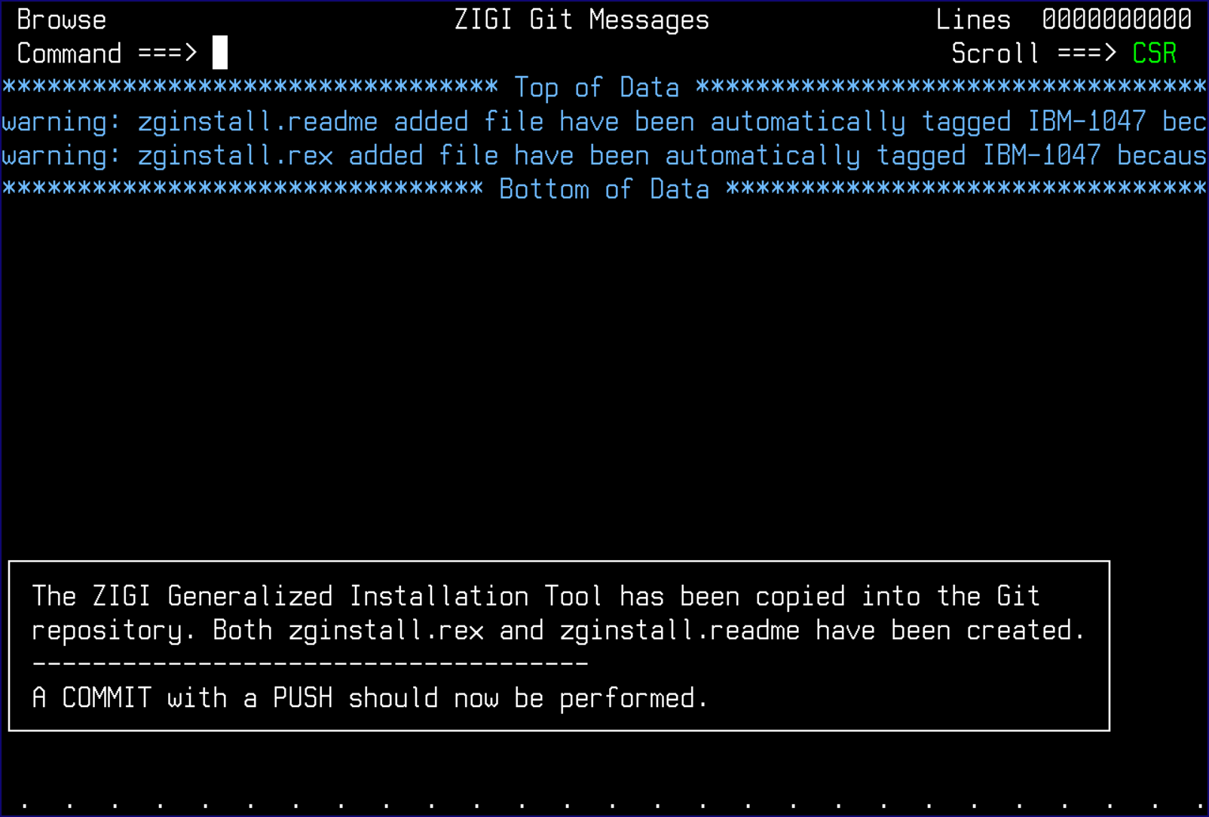

A git add is performed automatically. Perform a Commit and Push to lock in this update.

# Appendix C: Learning Resources

The following are some links to webpages to learn more about Git:

* <https://danielmiessler.com/study/git/>
* <https://www.atlassian.com/git>
* <https://git-scm.com/>
* <http://rogerdudler.github.io/git-guide/>
* [https://guides.github.com/introduction/git-handbook/#basic-git](https://guides.github.com/introduction/git-handbook/)
* <https://github.github.com/training-kit/downloads/github-git-cheat-sheet.pdf>
* Additional links: <https://try.github.io/>

# Appendix D: User Exits

ZIGI version 3.10 includes new user exits. All exits are provided as samples that must be updated by each site and then installed using the correct exit name.

Available exits include:

|  |  |
| --- | --- |
| **User Exit** | **Description** |
| ZIGIXIT0 (SAMPXIT0) | Return the location of the Dovetail getpds and putpds commands if they are not found in the PATH. |

The exit driver is ZIGIEXIT, which is called passing the exit number:

Return = zigiexit(*#*) OR

Return = zigiexit(*# data*)

The *#* maps to the exit number (for example: 0 to ZIGIXIT0) and *data* is any information that the exit may require. Each exit returns the requested information.

# Appendix E: Common Problems

This is a partial list of common problems you may encounter:

* Failure in the cp command attempting to copy a z/OS data set, or z/OS PDS member, to USS. This is typically caused by the z/OS data set being opened (for example: ISPF Browse).
* Failure using the Clone or Remote ZIGI commands due to an access failure. This may be caused by your ssh public key on the active LPAR not being registered with the remote server.

